RIAIMH CARE RACIAL Equity Series
“The Art of Difficult Conversations”

Session 1: October 21 or November 4, 2020

Name:

Facilitators: Robert T. Jones,
Chief Empowerment Officer
T. Lee Associates
Danita Roberts
HFA Program Manager
Meeting Street
“On some positions cowardice asks the question, “Is it politic?”, vanity asks the question, “Is it popular?”, but conscience asks the question, “Is it right?”. – Anonymous

Table of Contents

Session Learning Outcomes & Agenda 4

Creating a “Safe Enough” space for dialogue 5
Hot Buttons & Triggers!!

Conflict is 6

How do I respond to conflict 7

Conflict Cycle/Conflict Management Style 8-11

Types of Conflict 12

Responses to Conflict 13

Practice Session #1 Concerns/Issues in your life 14

Understanding Process Approach to Intentional Dialogue 15-17

Practice Session #2 Understanding Process Practice 18

Questions/Comments 19

Active Listening 20

Tips for Effective Communication 21

Hints for De-Escalating a Conflict 22

LEARNING OUTCOMES
“Increased understanding will naturally lead to mutual respect.”
Dalai Lama

- Understand
Conflict Cycle/Conflict Style & Impact on having difficult conversations
Challenges, benefits of having difficult conversations
- The Understanding Process and difficult dialogues
Develop empathy and understanding
- Share your story
- Share your triumphs
- Inspiring and Empowering each other

AGENDA

Welcome
Mentimeter check in
Navigating this session
Goals, Agenda, Creating “Safe Enough” space
Difficult Conversations; Challenges & Benefits
Personal Responses to Conflict
Conflict Cycle/Conflict style
Types of Conflict
Responses to Conflict
The Understanding Process
Tips for Effective Communication
START…., STOP…., CONTINUE
Mentimeter check out
Closing
Creating a “Safe Enough” space for Dialogue
Be Open & Honest
Suspend Judgement
Vegas Rule
Listen; content, meaning, feelings
Challenge by Choice
And/Both Approach
Practice Whatever You Discover!

CONFLICT IS…..
“The point of dialogue is not to create comfort
but to challenge culture and power.”
Paolo Freire

- In a sentence, produce a definition of conflict
- What messages have you received about conflict from:
- Your family

- Your friends

- Society

How do I respond to conflict?
Family – Friends – Job – Strangers
RESPONSE | FAMILY | FRIENDS | JOB | STRANGERS
Avoid the person.
Change the subject.
Admit you are wrong even when you are not.
Give in.
Pretend to agree.
Whine or complain until you get your way.
Play the martyr. Give in but let the person know you are suffering.
Try to reach a compromise.
Try to understand the other person’s point of view.
Try to find a solution both of you will find acceptable.
Be persistent. Wear the person down.
Use your authority. Order person to obey you.
Use sarcasm or ridicule.
Defend your position.
Use power to win your position.
Acknowledge the conflict & work for consensus.
Try to manipulate to gain the advantage.
Others?

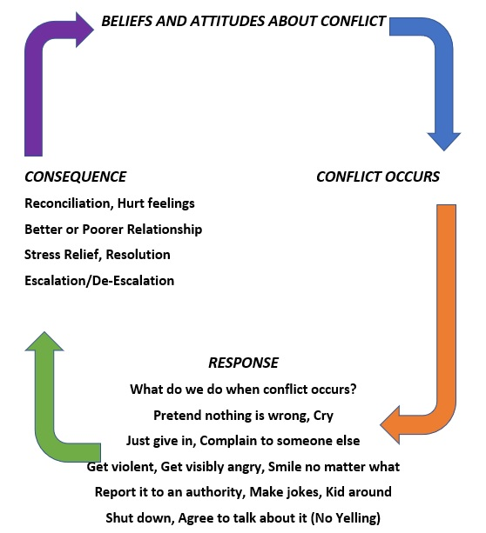

Conflict Management Styles Assessment
Source: Reginald (Reg) Adkins, PhD, Elemental Truths http://elementaltruths.blogspot.com/2006/11/conflict-management-quiz.html

We each have our own way of dealing with conflict. The techniques we use are based on many variables such as our basic underlying temperament, our personality, our environment and where we are in our professional career. However, by and large there are five major styles of conflict management techniques in our toolbox. In order to address conflict, we draw from a collaborating, competing, avoiding, accommodating, or compromising style of conflict management. None of these strategies is superior in and of itself.

How effective they are depending on the context in which they are used.

Each statement below provides a strategy for dealing with a conflict. Rate each statement on a scale of 1 to 4 indicating how likely you are to use this strategy.

1 = Rarely 2 = Sometimes 3 = Often 4 = Always

Be sure to answer the questions indicating how you would behave rather than how you think you should behave.

1. I explore issues with others so as to find solutions that meet everyone’s needs. _______
2. I try to negotiate and adopt a give-and-take approach to problem situations. _______
3. I try to meet the expectations of others. _______
4. I would argue my case and insist on the merits of my point of view. _______
5. When there is a disagreement, I gather as much information as I can and keep the lines of communication open. _______
6. When I find myself in an argument, I usually say very little and try to leave as soon as possible. _______
7. I try to see conflicts from both sides. What do I need? What does the other person need? What are the issues involved? _______
8. I prefer to compromise when solving problems and just move on. _______
9. I find conflicts challenging and exhilarating; I enjoy the battle of wits that usually follows.
_______
10. Being at odds with other people makes me feel uncomfortable and anxious. _______
11. I try to accommodate the wishes of my friends and family. _______
12. I can figure out what needs to be done and I am usually right. _______
13. To break deadlocks, I would meet people halfway. _______
14. I may not get what I want but it’s a small price to pay for keeping the peace. _______
15. I avoid hard feelings by keeping my disagreements with others to myself. _______

How to score the Conflict Management Assessment

As stated, the 15 statements correspond to the five conflict resolution styles. To find your most preferred style, total the points in the respective categories. The one with the highest score indicates your most commonly used strategy. The one with the lowest score indicates your least preferred strategy. However, if you are a leader who must deal with conflict on a regular basis, you may find your style to be a blend of styles.

Style Corresponding Statements: Total:

Collaborating: 1, 5, 7 _______

Competing: 4, 9, 12 _______

Avoiding: 6, 10, 15 _______

Accommodating: 3, 11, 14 _______

Compromising: 2, 8, 13 _______

Brief Descriptions of the Five Conflict Management Styles

Collaborating Style: Problems are solved in ways in which an optimum result is provided for all involved. Both sides get what they want, and negative feelings are minimized.
Pros: Creates mutual trust; maintains positive relationships; builds commitments.
Cons: Time consuming; energy consuming.

Competing Style: Authoritarian approach.
Pros: Goal oriented; quick. Cons: May breed hostility.

Avoiding Style: The non-confrontational approach.
Pros: Does not escalate conflict; postpones difficulty.
Cons: Unaddressed problems; unresolved problems.

Accommodating Style: Giving in to maintain relationships.

Pros: Minimizes injury when we are outmatched; relationships are maintained.
Cons: Breeds resentment; exploits the weak.

Compromising Style: The middle ground approach.
Pros: Useful in complex issues without simple solutions; all parties are equal in power.
Cons: No one is ever really satisfied; less than optimal solutions get implemented.

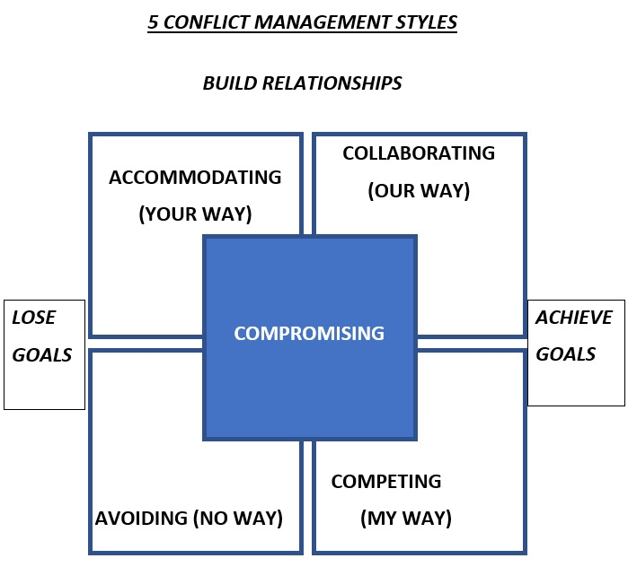

WEAKEN RELATIONSHIPS

TYPES OF CONFLICT
“It is not the difference which immobilizes us, but silence. And there are so many silences to be broken.”
Audre Lourde

- Internal – a conflict that occurs within oneself.

- Interpersonal – a conflict among 2 or more people.

- Intragroup – a conflict within a group. (Groups can be institutions, organizations, any group of people who share a specific role or identity).

- Intergroup – a conflict among 2 or more groups.

- International – a conflict among 2 or more nations.

- Global – a conflict that directly or indirectly affects all people and nations in the world

RESPONSES TO CONFLICT
“We don’t see things as they are; we seem them as we are.”
Anais Nin

Hard Response
Hard responses to conflict involve confrontation. Confrontation in response to conflict means a person expresses anger, verbal, or physical threats or aggression. It may also mean the person resorts to bribery or to punishments like withholding money, favors, or affection. These actions show a win-lose attitude toward conflict or that someone must win and the other lose in a conflict. This attitude prevents cooperation and keeps people from reaching a mutually satisfying solution.

Soft Response
Soft responses to conflict involve avoidance. People avoid conflict by withdrawing from the situation, ignoring the problem or denying their feelings. Avoidance may help in the short run. Avoidance can cause self-doubt and make a person feel anxious about the future. The conflict may never be resolved.

Principled Response
A principled response to conflict involves communication. Communication means participating in a common understanding, not necessarily agreeing. In order for people to cooperate, they must first communicate. People in conflict who seek first to understand the other person’s side, then be understood, produce win-win solutions.

PRACTICE SESSION #1 CASE STUDY

CONCERNS/ISSUES IN YOUR LIFE
“The greatest evil in the world is not anger or hate, but indifference.”
Elie Wiesel

Concerns/Issues in your life
Come up with a conflict that involves each
- Family
- Work
- Strangers
Role play the conflicts using the 3 different responses

The Understanding Process Approach to Intentional Dialogue
Dr. Deborah Flick

The Understanding Process Approach to Intentional Dialogue is a way of holding a conversation about anything, especially difficult, controversial issues in which views are openly shared, each other’s perspectives, beliefs, and values are deeply understood, and creative possibilities for positive change emerge.
Typically, when we talk about differences, issues get polarized and the discussion turns to who’s right, who’s wrong, and who’s to blame.
In contrast, the Understanding Process Approach to Intentional Dialogue is beneficial because it:
- Increases respect
- Builds trust
- Only takes one, you can make a difference
- Enhances creativity and innovation
- Encourages looking at situations from different points of view (including one’s own) without becoming polarized
- Helps us to "stay with and explore our differences" in ways that can kindle inspired ideas and actions
- Increases understanding people from their point of view and replaces judging and blaming with goodwill and collaboration
- Helps us to see when we need to agree with each other and when we don’t (The Understanding Process challenges the assumption that we have to agree with each other to get along.)
- Helps people to see each other as the unique, complex human beings that we are.
- Improves the way people with strong differences regard and communicate with each other.
- Lessens the tendency for people to (negatively) stereotype each other
- Increases willingness to cooperate and collaborate (because it builds respect and lessens the tendency to polarize people and issues).
- Builds solid, flexible, respectful working relationships.
- Fosters inclusion rather than divisiveness.
- Increases our courage and confidence to productively address rather than avoid differences.
- Helps people to be flexible and productive in the face of constant change.

Key to practicing the Understanding Process is the knowledge that understanding someone from their point of view does not necessarily mean agreeing with them. Nor does it mean giving up one’s own beliefs or values.

UNDERSTANDING PROCESS
“Every part of the earth is sacred… We are part of the earth as it is a part of us… All belong to the same family.” – Chief Seattle

THE DOUBTING, (CONVENTIONAL DISCUSSION), AND
UNDERSTANDING PROCESS

THE DOUBTING PROCESS

Premise:
- Only one right answer.

Goal:
- To be right and to win.

Attitude:
- Evaluating and critical

Focus:
- “What’s wrong with this picture?”

Behaviors

Listening:
- Accept nothing at face value
- Plan rebuttal.
- Talk more than you listen.

Inquiring:
- Ask questions that support your own perspective and challenge the other person’s.
- Interrogate the other person.
- Require evidence/proof.

Advocating:
- Assert own position.
- Describe flaws and require proof.

Role:
- Devil’s advocate.

Outcome:
- Debate

THE UNDERSTANDING PROCESS

Premise:
- Multiple valid answers and views.

Goal:
- To understand and to learn.

Attitude:
- Curious and open.

Focus:
- “What’s new? Of value? To learn?”

Behaviors

Listening:
- Accept info as true for the giver.
- Reflect, instead of react.
- Listen more than you talk.

Inquiring:
- Ask questions to clarify and deepen understanding and see it through their eyes.
- Explore assumptions.
- Suspend judgment.

Advocating:
- Offer your ideas as yours only.
- Explore alternative viewpoints.

Role:
- Learner.

Outcome:
- Dialogue.

PRACTICE SESSION #2
The Understanding Process

- We will break into triads
- For each statement
- You have 4-6 minutes per statement
- In each triad, one person will be
- A – Agree with statement (use doubting process)
- B – Disagree with statement (use understanding process)
- C – Summarize what was said
- D - Observer

STATEMENTS

- Abortion should not be legal.
- This age of “Cancel Culture” is ruining the US as we know it… ALL our statues are history.
- We should not have different months for celebrating different groups like Black History Month, Pride Month, LatinX Month,
- etc.
- These Black Lives Matter protests have gotten out of hand with the rioting and destruction of property. Martial law should be imposed in those cities that are out of control.

QUESTIONS/COMMENTS

START….

STOP….

CONTINUE….

ACTIVE LISTENING

ASKING CLARIFYING QUESTIONS
- To help you understand/clarify what has been said
- To get more information
- To elicit another point of view

EMPOWERING
- The other person to express her/his ideas by conveying your interest in hearing their point of view

RESTATING
- The other person’s basic ideas and facts to indicate you are listening
- Show you understand what has been/is being said
- Check your interpretation of what has been/is being said for accuracy and intention

GIVING VOICE
- To the speaker’s basic feelings as you perceive them
- To show you are aware of how the other person feels
- To indicate an understanding of how the other person feels
- To allow the other person to hear their feelings expressed by another person, which may help them clarify their state of mind or being

ACKNOWLEDING
- The efforts and worth of the other person by stating your appreciation of those efforts
- By recognizing the value to them of their feelings and point of view

SUMMARIZING
- The major ideas and feelings which have been expressed to review the ground covered by the dialogue
- To pull together important ideas and facts
- To establish a common ground for further discussion
TIPS FOR EFFECTIVE COMMUNICATION

- Answer or acknowledge what has been said, rather than express an emotional reaction.

- Recognize that there are some basic differences in the ways people communicate, such as through the different uses of words, tone, volume, and body language.

- Be willing to accept others’ reaction to your words without getting defensive.

- If you are having difficulties communicating with a particular person, try to identify what the barriers are and how you can eliminate them.

- Don’t make assumptions or rely on rumors.

- Practice Careful listening skills, (content, meaning, and feeling).

- Speak for yourself.

- Rephrase what you think you heard & ask for clarification when necessary.

- Clarify unclear points when asked.

HINTS FOR DE-ESCALATING A CONFLICT

- Take a deep breath to stay relaxed.
- Look the other person in the eye, with both either sitting or standing.
- Speak softly & slowly.
- Keep your legs & arms uncrossed and do not clench fists or purse your lips.
- Keep reminding yourself: “We can find a win-win resolution to this,” and remind the other person too.
- If necessary, ask for a break to collect your thoughts or release pent-up tension.
- Give “I” messages.
- Reframe what the other person has said, asking for clarification when necessary.
- Watch your language, words that escalate a conflict are never, always, unless, can’t, won’t, don’t, should and shouldn’t. Words that de-escalate a conflict are maybe, perhaps, sometimes, what if, seems like, I feel, I think, and I wonder.
- Really listen to what the other person is saying, with the goal of truly understanding that person’s point of view.
- Affirm and acknowledge the other person’s position.
- Ask questions that encourage the other person to look for a solution. Ask open-ended questions.
- Keep looking for alternative ideas to resolve your dispute so that both of you have your needs met.

