RIAIMH CARE RACIAL Equity Series
“POWER & PRIVILEGE”

January 20, 2021

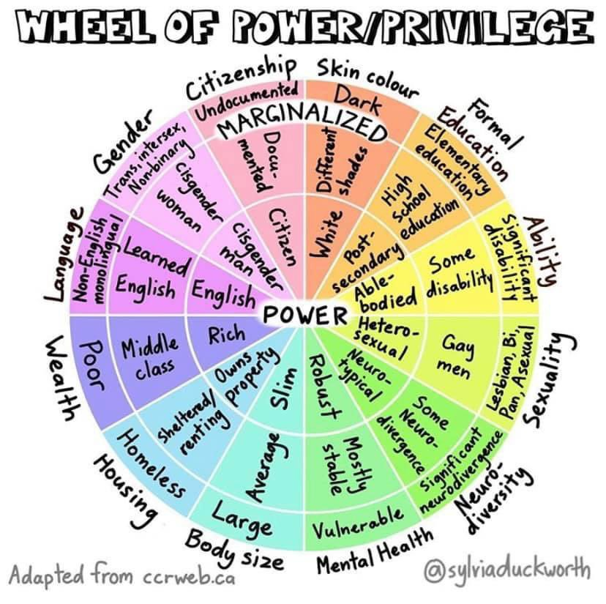

Name:

Facilitators: Robert T. Jones,
Chief Empowerment Officer
T. Lee Associates
Danita Roberts
HFA Program Manager
Meeting Street
“On some positions cowardice asks the question, “Is it politic?”, vanity asks the question, “Is it popular?”, but conscience asks the question, “Is it right?”. – Anonymous

Table of Contents

Session Learning Outcomes & Agenda 4

Creating a “Safe Enough” space for dialogue 5

Cultural Humility 6

Vocabulary 7

Privileged & Marginalized Group Patterns 8

Daily Effects of Privilege 11

LEARNING OUTCOMES
“Increased understanding will naturally lead to mutual respect.”
Dalai Lama

- Understand earned & unearned privilege.
- Understand concept of Cultural Humility.
- Explore role of power based on identity & position.

AGENDA
- Welcome
- Menti.com
- Agenda/Learning Outcomes/Safe Enough Space
- Cultural Humility
- Vocabulary
- POWER & PRIVILEGE
- Menti.com
- Closing

Creating a “Safe Enough” space for Dialogue

- Speak from our own experiences and perspectives.

- Listen generously to the experiences and perspectives of others, creating supportive space for each person to learn.

- Actively resist making assumptions about one another.

- Refrain from fixing, saving, advising, or correcting each other.

- Be mindful of “taking space and making space” to ensure everyone has opportunities to speak and to listen.

- Expect and accept non-closure because the work of disrupting racism is ongoing.

- Be willing to be challenged to disrupt racist patterns, both by the activities and discussions and by other participants.

- Respect the confidentiality of personal information and stories shared here.

Cultural Humility

- Cultural Competency
A defined set of values and principles, and demonstrated behaviors, attitudes and structures that enable employees and leaders to work effectively cross-culturally.
Managing Diversity at Duke University: A Toolkit for Managers: Cultural Competency
- Cultural Competency
acknowledges that, while people develop a more or less automatic depth of understanding of the subject positions and cultures into which we are born and socialized, achieving something like that depth of understanding of other subject positions and other cultures is far more difficult, but not impossible.
- Cultural Dexterity
Cultural Dexterity represents an advanced approach to cultural competence required in today’s diverse global settings. Rather than a static learning specific to only one national, ethnic, generational, or other group, Cultural Dexterity combines cultural knowledge, emotional intelligence, and interpersonal skills that can be adapted to achieve improved results in any cross-cultural situation.
Korn Ferry Institute
- Cultural Humility
The National Institutes of Health (NIH) defines cultural humility as “a lifelong process of self-reflection and self-critique whereby the individual not only learns about another’s culture, but one starts with an examination of their own beliefs and cultural identities.” The term was first coined in 1998 by healthcare professionals Melanie Tervalon and Jann Murray-García, who originally described cultural humility as a tool to educate physicians to work with culturally, ethnically, and racially diverse populations in the United States.
The concept, however, carries meaning for any clinical researcher or social advocate who is studying and/or working with someone different from themselves – in terms of race, ethnicity, gender identity, religion, sexual orientation, socioeconomic status, or geographic location – in any cultural context and in any part of the world.

- We move between several different cultures – often without even thinking about it.
- Cultural humility is distinct from cultural competency and reflexivity.
- Cultural humility requires historical awareness.
Vocabulary
A. A social identity used interchangeably with biological sex in a system that presumes if one has male characteristics, one is male, and if one has female characteristics, one is female.
B. The system of ordering a society in which people are divided into sets based on perceived social or economic status.
C. A system that maintains advantage and disadvantage based on social group memberships and operates, intentionally and unintentionally, on individual, institutional, and cultural levels.
D. One’s natural preference in sexual and/or romantic partners.
E. A category that describes membership to a group based on real or presumed common ancestry, shared languages and/or religious beliefs, cultural heritage and group history.
F. The sense of self, providing sameness and continuity in personality over time; the condition of being oneself and not another.
G. Unearned access to resources only readily available to some people as a result of their advantaged social group membership.
H. A socio-historical category used to divide people into populations or groups based on physical appearance, such as skin color, eye color, hair color, etc.
I. The ability to decide who has access to resources; the capacity to direct or influence the behavior of others, oneself, and/or the course
of events.

- Power

- Privilege

- Oppression

- Race

- Ethnicity

- Personal Identity

- Gender

- Sexual
Orientation

9. Class

Privileged and Marginalized Group Patterns
Privileged Groups
- Greater access to power and resources
- Make the Rules!
- Define what is normal, “right,” the “Truth”.
- Assumed to be leader, smarter, competent...
- Given the benefit of the doubt.
- Often unaware of privileged group membership and privilege
- Less aware about exclusive and discriminatory treatment of marginalized group
- Are more comfortable with members of marginalized groups who share similar behaviors, appearance, and values to them.
- Hold to privileged group cultural beliefs, often without examination.
- Collude, and if challenge, risk being ostracized/punished.
- Focus on “how far we’ve come”!

Marginalized Groups
- Less access to power and resources
- Often seen as less than, inferior, deficient...
- Often assimilate, collude, abide by the rules, try to fit in...
- Track the daily indignities they experience, very aware of oppression.
- Punished if challenge the status quo.
- Have their truth and experiences questioned and often invalidated.
- Know more about members of privileged groups than privileged group members know about them.
- Often struggle with finding a balance between who they are and who they are told they need to be to be “acceptable.”
- Often struggle with finding their voice and speaking up to challenge
- Focus on “how far we need to go”.

Key Concepts of Privileged/Marginalized Group Dynamics
- Not always about numbers
- Visible and Invisible; Innate and Chosen.
- Multiple Group Memberships
- Not always about individual behaviors or feelings
- You didn’t ask for it and you can’t give it back.
PRIVILEGED GROUP |  | MARGINALIZED GROUP
Late 30’s to 50’s | 1. Age | Younger; Older
White | 2. Race | Person of Color; People who identify as Biracial/Multiracial
Male | 3. Sex Assigned at Birth | Female; Intersex
Cisgender: Appearance and behaviors are congruent with the Gender Binary System ~ either masculine OR feminine | 4. Gender Identity and  Gender Expression | Transgender; Gender Nonconforming; Gender Queer; Androgynous
President, Vice Presidents, Deans, Directors, Faculty, Supervisors | 5. Hierarchical Level | Students, Graduate Teaching Assistants, direct service staff
Heterosexual | 6. Sexual Orientation | Gay; Lesbian; Bisexual; Queer; Questioning
Upper class; Upper middle class; Middle class | 7. Social Class | Working class; Living in poverty
Graduate or 4-year degree; highly valued school; private school | 8. Educational Level; Credential; Certificate | High school degree; 1st generation to college; less valued school; public school
Christian (Protestant; Catholic) | 9. Religion/Spirituality | Muslim, Jewish, Agnostic, Hindu, Atheist, Buddhist, Spiritual, LDS, Jehovah Witness, Pagan, …
U.S. born | 10. National Origin | “Foreign born;” Born in a country other than the U.S.
Currently “able-bodied” | 11. Ability Status | People with a physical, mental, emotional and/or learning disability; People living with AIDS/HIV+
“American;” Western European heritage | 12. Ethnicity/Culture | Puerto Rican; Navajo; Mexican; Nigerian; Chinese; Iranian; Russian; Jewish…
Fit society’s image of attractive, beautiful, handsome, athletic… | 13. Size, Appearance, Athleticism | Perceived by others as too fat, tall, short, unattractive, not athletic…
Proficient in the use of “Standard” English | 14. English Literacy | Use of “non-standard” English dialects; have an “accent”
Legally married in a heterosexual relationship | 15. Marital Status | Single; divorced; widowed; same sex partnership; unmarried heterosexual partnership…
Parent of children born within a 2-parent heterosexual marriage | 16. Parental Status | Unmarried parent; do not have children; non-residential parent; LGBTQ parents…
More years on campus | 17. Years of experience | New; little experience on campus
U.S. citizen | 18. Immigration Status | People who do not have U.S. citizenship, are undocumented
Suburban; valued region of U.S. | 19. Geographic region | Rural; some urban areas…less valued region
Light skin; European/Caucasian features | 20. Skin color; phenotype | Darker skin; African, Asian, Aboriginal features…
Nuclear family with 2 parents in a heterosexual relationship | 21. Family Status | Blended family; single-parent household; grandparents raising grandchildren; foster family…
Extrovert; task-oriented; analytical; linear thinker | 22. Work Style | Introvert; process-oriented; creative; circular thinker

Daily Effects of Class Privilege

- I have options for choosing different lifestyles.
- I do not have to feel apologetic for whatever my life is.
- I can choose and get whatever kind of health care I prefer.
- I can assume that money will not keep me from getting whatever job, career I would like.
- I can assume that money will not be a factor in limiting where I can choose to live.
- If I choose a lower-paying job I always know that I always have a family to fall back on for financial support.
- I can get a higher education, often a the most prestigious schools, even though my grades and test scores may not be the very top.
- I will have access to college loans because I have the necessary collateral.
- I or my family members know people who can provide access to jobs, schools, housing, financial resources, and other benefits.
- I can afford rent deposits, utility, and phone deposits, etc. whenever I need them, or have an acceptable co-signer, or have the waived because of my income level and good credit rating.
- I can take vacations and travel as often as my work permits.
- I can choose when I will take a vacation.
- I will be able to take care of myself and my family after I retire.
- I will be able to pass my wealth on to my children.
- I am not forced to spend all my resources and my personal time taking care of sick and elderly parents.
- I can make sure my children attend school where they will learn to read, write, and develop other skills they will need to get a job.
- I am not portrayed as dumb and stupid on TV and on the movies.
- I learned early on that I can assert my rights and expect that they will be addressed.
- Other people will not assume that I am dirty, lazy, unmotivated, and ignorant.
- Others will not assume that I have no interest in anything beyond my own physical needs.
- As a child I will not be placed in a lower academic track or discouraged from taking certain classes because of my economic status.
- If I achieve outstanding accomplishment of any kind, others will not think it is because I am an exception and different from other people of my economic group.
- I do not have to fight a tendency to feel ashamed of myself and my backgrounds because of other people’s attitudes about my group.
- I have been taught to assume that it is all right to express my opinion and to analyze and criticize things.

Daily Effects of Male Privilege

As a child:
- I can notice that the teacher will notice me and call me frequently.
- My gender will not cause my teachers and counselors to discourage me from taking math or science or participating in sports.
- I am encouraged by my community to assert myself and take risks.
- I learn from my elders and peers to like competition and to not fear conflict - attitudes that will serve me well in the work world as an adult.
- I am much less likely than my sisters to be a victim of sexual abuse.
- I am expected to be independent and to be able to take care of myself.
- I can find role models of my gender everywhere I look in every possible area of achievement (Work, arts, sports, etc.)
- I learn to expect that my needs will be put above those of the women in my life and that it is OK to “be taken care of.”

As an adult:
- I can be pretty sure that I will not face daily sexual harassment walking down the street, on the job or anywhere.
- I can pretty much go where I want when I want without having to deal with the fear of rape.
- I don’t have to wonder if I will be among the “one out of every four” who will be a victim of domestic violence.
- The style of communication, problem solving, and social interaction that I have been taught all my life will be accepted and valued way of doing things; I will not have to “play a role” in order to be seen as competent and intelligent.
- I can know that most people will judge and value me for characteristics other than my physical attractiveness.
- I will not automatically be viewed as “less attractive” as soon as I reach my middle age.
- I am probably earning a higher wage than women with comparable qualifications and job responsibilities.
- I have a better chance than my sister to advance in my job, and me advantage will be greater the higher I go.
- I can put maximum time into my career and/or professional pursuits by avoiding domestics chores without being condemned as an “inadequate man”.
- I can take a job, get a promotion, receive a good grade without having my peers suspect that I got it because of my gender.
- I can state my opinion in a strong term without being characterized as “harsh, shrill, emotional or bitchy”.
- I can express anger without being condemned as emotional or hostile.
- I can know that my choice will be heard, and my opinions and ideas will be taken seriously in group settings even if I am the only person in the group.
- I can tell doctors about my problems or symptoms I am experiencing and know my concerns will not be dismissed as “hysteria” or misdiagnosed as a “nervous disorder”.
- When I am treated for a medical condition, I can be confident that the research on which the treatment is based was done on members of my gender, so is more likely to be appropriate and safe for me.
- I can usually expect nurturing and emotional support from women.
- I can often avoid responsibility for pregnancy.
- My job o career will not be jeopardized by pregnancy.
- I can assume that the physical space around me is primarily my space.
- I can end a relationship with relatively less fear of losing economic security.

Daily Effects of Christian Privilege

- Positive qualities such as compassion, kindness, and caring are described as being synonymous with my religion values (i.e., “Good Christian Values”).
- I do not hear negative comments about my group being over-represented in banking, media, etc.
- I never feel that my physical appearance is being judge based on my religion.
- I can assume that my major holidays will be widely acknowledge and celebrated.
- I know that the “God” of my country’s coinage, Pledge of Allegiance, America the Beautiful and legal oaths is the God of my religion.
- I never have to worry that I or my children will miss an important exam, meeting, or event because my town, employer, professional group or school system schedule it on a major holiday.
- I do not have to use up personal days or vacation days at work in order to observe my holidays.
- My children are not marked “absent” for holiday observance.
- I can behave gratingly, competitively, frugally, insularly, and not worry that my behavior will reflect on or be attributed to my religious believes.
- I regularly heard and learned that my country’s values and beliefs are rooted in the teachings of my religious group.
- I can find foods to observe my religious holidays in virtually any supermarket in town.
- I can readily find greeting cards, gift wrap, etc. for my major holidays in virtually any store selling this type of item.

Daily Effects of White Privilege

- I can if I wish arrange to be in the company of people of my race most of the time.
- If I should need to move, I can be pretty sure of renting or purchasing housing in an area which I can afford and in which I would want to live.
- I can be pretty sure that my neighbors in such a location will be neutral or pleasant to me.
- I can go shopping alone most of the time, pretty well assured that I will not be followed or harassed.
- I can turn on the television or open to the front page of the paper and see people of my race widely represented.
- When I am told about our national heritage or about “civilization,” I am shown that people of my color made it what it is.
- I can be sure that my children will be given curricular materials that testify to the existence of their race.
- If I want to, I can be pretty sure of finding a publisher for this piece on white privilege.
- I can go into a music shop and count on finding the music of my race represented, into a supermarket and find the staple foods that fit with my cultural traditions, into a hairdresser’s shop and find someone who can cut my hair.
- Whether I use checks, credit cards or cash, I can count on my skin color not to work against the appearance of financial reliability.
- I can arrange to protect my children most of the time from people who might not like them.
- I can swear, or dress in second-hand clothes, or not answer letters, without having people attribute these choices to the bad morals, the poverty, or the illiteracy of my race.
- I can speak in public to a powerful male group without putting my race on trial.
- I can do well in a challenging situation without being called a credit to my race.
- I am never asked to speak for all the people of my racial group.
- I can remain oblivious of the language and customs of persons of color who constitute the world’s majority without feeling in my culture any penalty for such oblivion.
- I can criticize our government and talk about how much I fear its policies and behavior without being seen as a cultural outsider.
- I can be pretty sure that if I ask to talk to “the person in charge,” I will be facing a person of my race.
- If a traffic cop pulls me over or if the IRS audits my tax return, I can be sure I haven’t been singled out because of my race.
- I can easily buy posters, postcards, picture books, greeting cards, dolls, toys, and children’s magazines featuring people of my race.
- I can go home from most meetings of organizations I belong to feeling somewhat tied in, rather than isolated, out-of-place, outnumbered, unheard, held at a distance, or feared.
- I can take a job with an affirmative action employer without having co-workers on the job suspect that I got it because of race.
- I can choose public accommodations without fearing that people of my race cannot get in or will be mistreated in the places I have chosen.
- I can be sure that if I need legal or medical help, my race will not work against me.
- If my day, week, or year is going badly, I need not ask of each negative episode or situation whether it has racial overtones.
- I can choose blemish cover or bandages in “flesh” color and have them more less match my skin.

Daily Effects of Heterosexual Privilege

- Immediate access to your loved one in case of accident or emergency.
- Public recognition and support for an intimate relationship (e.g., congratulations for an engagement).
- Expressing affection in most social situations and not expecting hostile or violent reactions from others.
- Living with your partner and doing so openly.
- Expressing pain when a relationship ends from death or separation and receiving support from others.
- Receiving social acceptance by neighbors, colleagues, and good friends.
- Learning about romance and relationships from fiction movies and television.
- Having role models of your gender and sexual orientation.
- Having positive and accurate media images of people with whom you can identify.
- Expecting to be around others of your sexuality most of the time. Not worrying about being the only one of your sexuality in a class, on a job, or in a social situation.
- Talking openly about your relationship, vacations, and family planning you and your lover/partner are doing.
- Easily finding a neighborhood in which residents will accept how you have constituted your household.
- Raise, adopt, and teach children without people believing that you will molest them or force them into your sexuality.
- Working in traditionally male or female dominated job and not feeling as though you are a representative of your sexuality.
- Paid leave from employment when grieving the death of your spouse.
- Not being asked “how does sex work for you?” or other too-personal questions by strangers.
- Sharing health, auto and homeowners’ insurance policies at reduced rates.
- Not having to hide or lie about women/men-only social activities.
- Acting, dressing, or talking as you choose without it being a reflection on people of your sexuality.
- The ability to teach about lesbians, gay men, and bisexuals without being seen as having a bias because of your sexuality or forcing a “homosexual agenda” on students. Property laws, filing joint tax returns, inheriting from your spouse automatically under probate laws.
- Joint child custody.
- Going wherever you wish and know that you will not be harassed, beaten, or killed because of your sexuality.
- Not worrying about being mistreated by the police or victimized by the criminal justice system because of your sexuality.
- Legal marriage to the person you love.
- Knowing that your basic civil rights will not be denied or outlawed because some people disapprove of your sexuality.
- Expect that your children will be given texts in school that support your kind of family unit and they will not be taught that your sexuality is a “perversion.”
- Freedom of sexual expression without fear of being prosecuted for breaking the law.
- Belonging to the religious denomination of your choice and know that your sexuality will not be denounced by its religious leaders.
- Knowing that you will not be fired from a job or denied a promotion based on your sexuality.
- Not being asked by your child’s school to only send one parent to “back to school” night as to not upset the other parents by having two same-sex partners in the class together.
- The ability to play a professional sport and not worry that your athletic ability will be overshadowed by your sexuality and the fact that you share a locker room with the same gender.
- Not having to worry about being evicted if your landlord finds out about your sexuality.
- Not having to “come out” (explain to people that you’re straight, as you can just assume, they will assume it)
- Knowing that people are not going to mutter about your sexuality if you come out to them.
- Knowing that being open with your sexuality is not going to change how people view you.
- Being able to have your partner from a different country be able to obtain citizenship in your country through marriage.
- Not having people think your sexuality is a mental health issue.
- Not having to worry that people will not let their children play with your children because of your sexuality.
- Not having to worry where you can move alone or with your spouse and have equal job opportunities abroad.

