RIAIMH CARE RACIAL Equity Series
“Me, Myself & I!”

November 18 & December 2, 2020

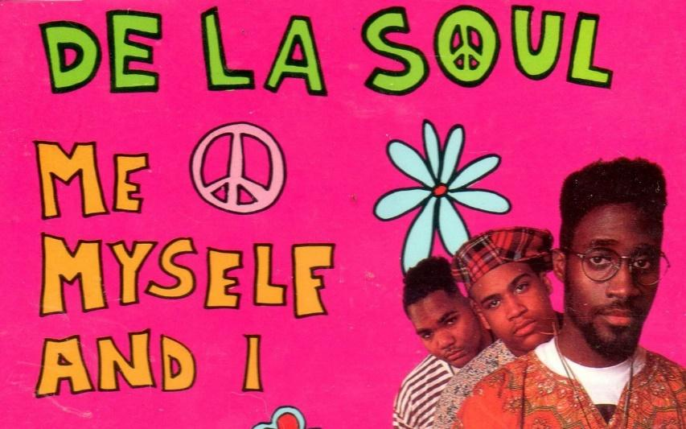

Name: _________________________

Facilitators: Robert T. Jones,
Chief Empowerment Officer
T. Lee Associates
Danita Roberts
HFA Program Manager
Meeting Street
Community is much more than belonging to something; it's about doing something together that makes belonging matter.
- Brian Solis

Table of Contents

Session Learning Outcomes & Agenda 4

Creating a “Safe Enough” space for dialogue 5

Definitions of Culture 6

Diversity Iceberg 7

Dimensions of Diversity 8

Circles of Identity 9-11

How do we get to thinking like we do? 12-14

Cycle of Socialization 14

LEARNING OUTCOMES
“Increased understanding will naturally lead to mutual respect.”
Dalai Lama

- To begin to develop trust and build new relationships
- To understand the Dimensions of Diversity
- To understand the Cycle of Socialization

AGENDA

Welcome
Agenda/Goals & Objectives
Comfort Zone/Safe Enough Space/Parking Lot
Dimensions of Diversity
How do we get to thinking like we do?
Cycle of Socialization
Closing

Creating a “Safe Enough” space for Dialogue
Be Open & Honest
Suspend Judgement
Vegas Rule
Listen; content, meaning, feelings
Challenge by Choice
And/Both Approach
Practice Whatever You Discover!

Definitions of Culture
Unless you learn to face your own shadows,
you will continue to see them in others,
because the world outside you is only a reflection of the world inside you. -Unknown

Culture is ……...

“The social heritage-the institutions, customs, conventions, values, skills, arts, modes of living - of a group of people feeling themselves members of a closely bound community and sharing a deep-rooted attachment and allegiance to it.”
-Harper Dictionary of Modern Thought

“Culture is a way of life of any society. It includes acquired knowledge, attitudes, values, behavior and communication style.”

“Culture is a set of expectations we have about the way things are or should be.”

“Culture is a lens or filter through which we see the world.”
-Communication Training Consultants Manual

… “the complex ways that people who form a community interact with each other.”
-Paul Kivel
“Uprooting Racism”

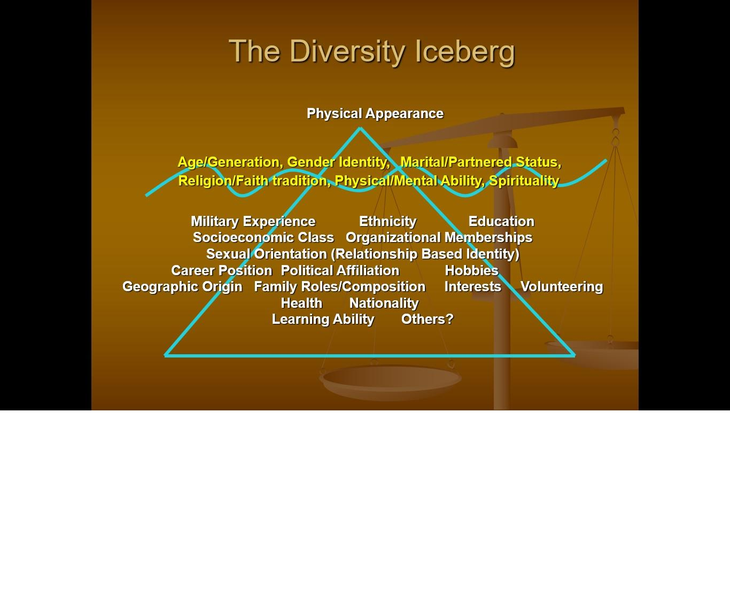

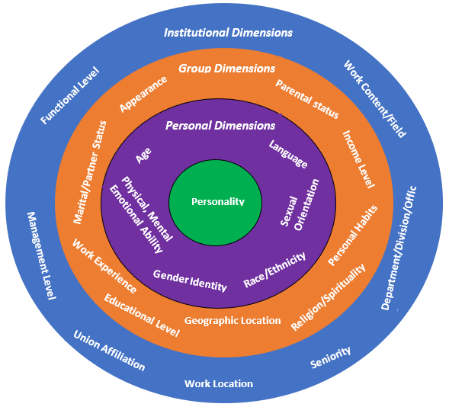

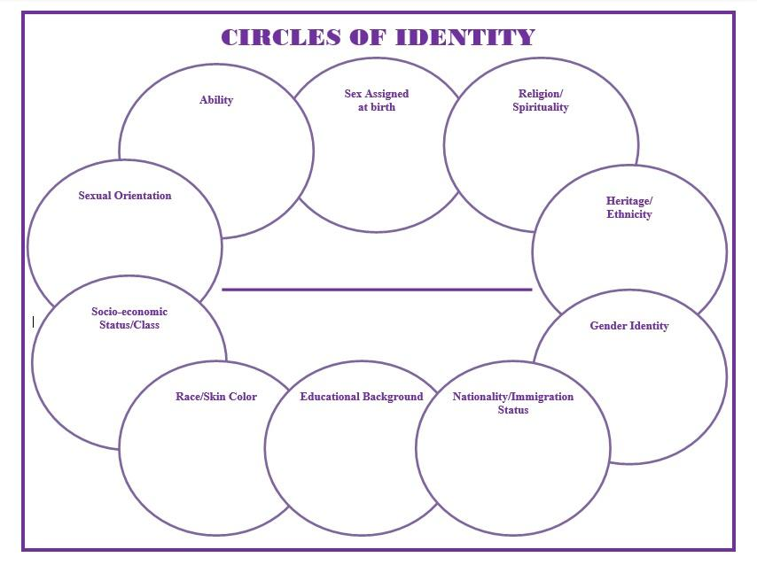

When was a time you felt good about being ________(insert identity)?

When was a time you did not feel so good about being ________(insert identity)?

What was a positive message you received about being _____________(insert identity).

What was a negative message you received about being _____________(insert identity).

WHO AM I?

What identities are you comfortable having conversations about with others? Why?

What identities are you uncomfortable having conversations about with others? Why?

How do others see you?

How do you see others?
“How Do We Get to Thinking Like We Do?”
When you were growing up, what messages (verbal and non-verbal)
Did you get from significant adults and others in your life?
Topic | The Message received | The source
Having a mental, physical, emotional disability
Being Male
Being Female
Being Your faith tradition/ religion
Being your specific race/nationality
Being biracial
Being an Athlete
Being an Immigrant
Asking for help
Topic | The Message received | The source
Helping others
Being Good Looking
Being Gay, Lesbian, Bi-sexual, Transgendered, Queer, Questioning
Being Poor
Being Wealthy

How do we get to thinking like we do?

- What do you think is meant by the term “hidden messages”?

- In what ways might the hidden messages about culture/identity people receive impact their interactions with people from their own culture/identity?

- How might they influence interactions with people from other cultures/identities?

- In what ways might the “hidden messages” about different cultures/identities you have received impact your assumptions about and interactions with others?

- What if any, has been the impact?

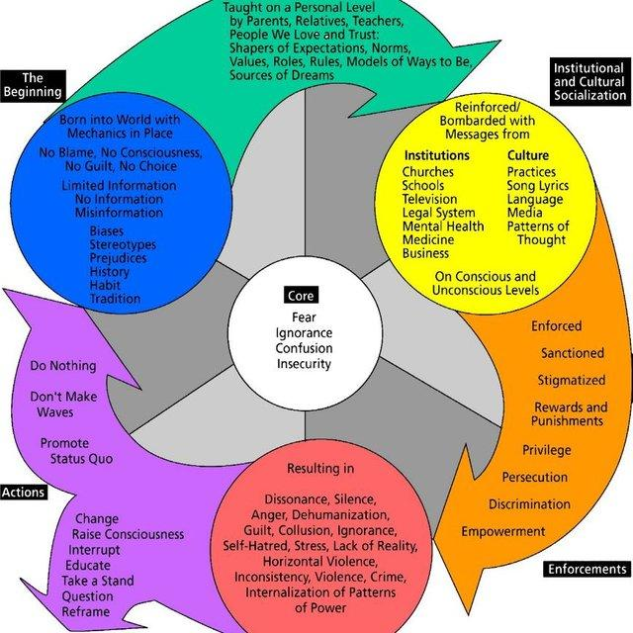
Cycle of Socialization

- The beginning of the cycle, depicted by the 1st circle, represents the situation into which we were born. We have no control over this. We are also born without bias, assumptions, or questions. We are either “lucky” to be born into a privileged situation or “unlucky” to born into an underprivileged situation.
- The 1st arrow represents that fact that our socialization process begins immediately. We are given a pink blanket if we are a girl or a blue one if we are boy. The rules and norms are already in place and we subtly (and in many cases not so subtly) are made aware of the rewards of conforming and the consequences of rebelling.
- The second circle represents the institutions that help shape our views and beliefs, and help instill within us prejudice or acceptance.
- The second arrow represents the way in which the instilling of ideas, beliefs, and behaviors reinforce the cycle of oppression. Behaving differently is not as simply as most of us think. We are rewarded for good behavior – conforming to the norms and standards. By the same token, we are punished for bad behavior – questioning or rebelling against oppressive societal norms.
- The third circle represents the devastating result upon all of us that this self-perpetuated cycle of oppression produces.
- The final arrow represents a point at which we all arrive – the results of the cycle. We are forced to make a decision, even if that decision is to do nothing. Doing nothing is the easier choice, especially for those who benefit from the perpetuation of the cycle: we are all victims of the cycle and we are all hurt by it. Oppression hurts the oppressed and the oppressor.
- And finally, it is the wheel that turns or enables any cycle. At the center or core of the cycle of socialization are fear, misunderstanding, insecurity, confusion, etc.

