RIAIMH CARE RACIAL Equity Series
“Harris Diversity Tenets & Racial Equity”

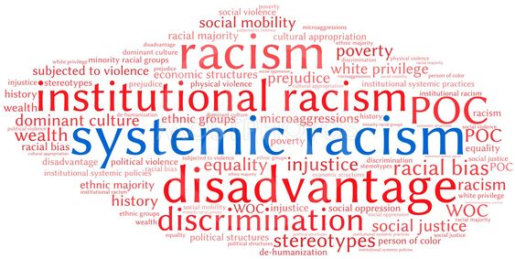

Name:

Facilitators: Robert T. Jones,
Chief Empowerment Officer
T. Lee Associates
Danita Roberts
HFA Program Manager
Meeting Street
“On some positions cowardice asks the question, “Is it politic?”, vanity asks the question, “Is it popular?”, but conscience asks the question, “Is it right?”. – Anonymous

Table of Contents

Session Learning Outcomes & Agenda 4

Creating a “Safe Enough” space for dialogue 5

Harris Diversity Tenets 6-7

Racial Equity Terms 8-11

Culture of White Supremacy 12-13
Pyramid of White Supremacy

What Do We Mean by Racial Equity 14

Racial Equity Looks the Same Across Systems 15

Racial Equity Framework/Lens 16

Resources/Glossary 17-33

LEARNING OUTCOMES
“Increased understanding will naturally lead to mutual respect.”
Dalai Lama

Understand:
- The Harris Tenets of Diversity
- The fundamentals of Racial Equity
- Racial Equity Foundations/Principles
- Key components of Racial Equity
- Impact across society and industry
- Share your story
- Share your triumphs
- Inspire and Empower each other.

AGENDA
- Welcome
- Mentimeter check in
- Goals, Agenda, Creating “Safe Enough” space
- Harris Diversity Tenets
- What do we mean by “Racial Equity?”
- Racial Equity Foundations/Principles
- Key terms/History
- Impact……
- Mentimeter check out
- Closing

Creating a “Safe Enough” space for Dialogue

- Speak from our own experiences and perspectives.

- Listen generously to the experiences and perspectives of others, creating supportive space for each person to learn.

- Actively resist making assumptions about one another.

- Refrain from fixing, saving, advising, or correcting each other.

- Be mindful of “taking space and making space” to ensure everyone has opportunities to speak and to listen.

- Expect and accept non-closure because the work of disrupting racism is ongoing.

- Be willing to be challenged to disrupt racist patterns, both by the activities and discussions and by other participants.

- Respect the confidentiality of personal information and stories shared here.

DIVERSITY-INFORMED INFANT MENTAL HEALTH TENETS

THE TENETS ARE A PRODUCT OF THE IRVING HARRIS FOUNDATION PROFESSIONAL DEVELOPMENT NETWORK

http://www.imhdivtenets.org
- Self-Awareness Leads to Better Services for Families: Professionals in the field of infant mental health must reflect on their own culture, personal values, and beliefs, and on the impact racism, classism, sexism, able-ism, homophobia, xenophobia, and other systems of oppression have had on their lives in order to provide diversity-informed, culturally attuned services on behalf of infants, toddlers, and their families.

STANCE TOWARD INFANTS AND FAMILIES
- Champion Children’s Rights Globally: Infants are citizens of the world. It is the responsibility of the global community to support parents, families, and local communities in welcoming, protecting, and nurturing them.
- Work to Acknowledge Privilege and Combat Discrimination: Discriminatory policies and practices that harm adults harm the infants in their care. Privilege constitutes injustice. Diversity-informed infant mental health professionals work to acknowledge privilege and to combat racism, classism, sexism, able-ism, homophobia, xenophobia, and other systems of oppression within themselves, their practices, and their fields.
- Recognize and Respect Nondominant Bodies of Knowledge: Diversity-informed infant mental health practice recognizes nondominant ways of knowing, bodies of knowledge, sources of strength, and routes to healing within diverse families and communities.
- Honor Diverse Family Structures: Families define who they are comprised of and how they are structured; no particular family constellation or organization is inherently optimal compared to any other. Diversity-informed infant mental health practice recognizes and strives to counter the historical bias toward idealizing (and conversely blaming) biological mothers as primary caregivers while overlooking the critical child-rearing contributions of other parents and caregivers including fathers, second mothers, foster parents, kin and felt family, early care and educational providers, and others.

PRACTICE/RESEARCH FIELD PRINCIPLES
- Understand That Language Can Be Used to Hurt or Heal: Diversity-informed infant mental health practice recognizes the power of language to divide or connect, denigrate or celebrate, hurt or heal. Practitioners strive to use language (including “body language,” imagery, and other modes of nonverbal communication) in ways that most inclusively support infants and toddlers and their families, caregivers, and communities.
- Support Families in Their Preferred Language: Families are best supported in facilitating infants’ development and mental health when services are available in their native languages.
- Allocate Resources to Systems Change: Diversity and inclusion must be proactively considered in undertaking any piece of infant mental health work. Such consideration requires the allocation of resources such as time and money for this purpose and is best ensured when opportunities for reflection with colleagues and mentors as well as on-going training and consultation are embedded in agencies, institutions, and systems of care.
- Make Space and Open Pathways for Diverse Professionals: Infant mental health workforces will be most dynamic and effective when culturally diverse individuals have access to a wide range of roles, disciplines, and modes of practice and influence.

BROADER ADVOCACY
- Advance Policy That Supports All Families: Diversity-informed infant mental health practitioners, regardless of professional affiliation, seek to understand the impact of social policies and programs on diverse infants and toddlers and to advance a just policy agenda for and with families.

©2012 by Irving Harris Foundation. All rights reserved.

Racial Equity Terms

Racism = race prejudice + social and institutional power
Racism = a system of advantage based on race
Racism = a system of oppression based on race
Racism = a white supremacy system

Racism is different from racial prejudice, hatred, or discrimination. Racism involves one group having the power to carry out systematic discrimination through the institutional policies and practices of the society and by shaping the cultural beliefs and values that support those racist policies and practices.

Racial equity is the condition that would be achieved if one's racial identity no longer predicted, in a statistical sense, how one fares. When we use the term, we are thinking about racial equity as one part of racial justice, and thus we also include work to address root causes of inequities, not just their manifestation. This includes elimination of policies, practices, attitudes, and cultural messages that reinforce differential outcomes by race or that fail to eliminate them.
- “A mindset and method for solving problems that have endured for generations, seem intractable, harm people and communities of color most acutely, and ultimately affect people of all races. This will require seeing differently, thinking differently, and doing the work differently. Racial equity is about results that make a difference and last.”

Structural Racism
- The normalization and legitimization of an array of dynamics – historical, cultural, institutional, and interpersonal – that routinely advantage Whites while producing cumulative and chronic adverse outcomes for people of color. Structural racism encompasses the entire system of White domination, diffused and infused in all aspects of society including its history, culture, politics, economics, and entire social fabric. Structural racism is more difficult to locate in a particular institution because it involves the reinforcing effects of multiple institutions and cultural norms, past and present, continually reproducing old and producing new forms of racism. Structural racism is the most profound and pervasive form of racism – all other forms of racism emerge from structural racism.
- For example, we can see structural racism in the many institutional, cultural, and structural factors that contribute to lower life expectancy for African American and Native American men, compared to white men. These include higher exposure to environmental toxins, dangerous jobs and unhealthy housing stock, higher exposure to and more lethal consequences for reacting to violence, stress, and racism, lower rates of health care coverage, access, and quality of care, and systematic refusal by the nation to fix these things.

White Supremacy
The idea (ideology) that white people and the ideas, thoughts, beliefs, and actions of white people are superior to People of Color and their ideas, thoughts, beliefs, and actions. While most people associate white supremacy with extremist groups like the Ku Klux Klan and the neo-Nazis, white supremacy is ever present in our institutional and cultural assumptions that assign value, morality, goodness, and humanity to the white group while casting people and communities of color as worthless (worth less), immoral, bad, and inhuman and “undeserving.” Drawing from critical race theory, the term “white supremacy” also refers to a political or socio-economic system where white people enjoy structural advantage and rights that other racial and ethnic groups do not, both at a collective and an individual level.

White Supremacy Culture refers to the dominant, unquestioned standards of behavior and ways of functioning embodied by the vast majority of institutions in the United States. These standards may be seen as mainstream, dominant cultural practices; they have evolved from the United States’ history of white supremacy. Because it is so normalized it can be hard to see, which only adds to its powerful hold. In many ways, it is indistinguishable from what we might call U.S. culture or norms – a focus on individuals over groups, for example, or an emphasis on the written word as a form of professional communication. But it operates in even more subtle ways, by actually defining what “normal” is – and likewise, what “professional,” “effective,” or even “good” is. In turn, white culture also defines what is not good, “at risk,” or “unsustainable.” White culture values some ways of thinking, behaving, deciding, and knowing – ways that are more familiar and come more naturally to those from a white, western tradition – while devaluing or rendering invisible other ways. And it does this without ever having to explicitly say so...
- An artificial, historically constructed culture which expresses, justifies, and binds together the United States white supremacy system. It is the glue that binds together white-controlled institutions into systems and white-controlled systems into the global white supremacy system.

The term white, referring to people, was created by Virginia slave owners and colonial rules in the 17th century. It replaced terms like Christian and Englishman to distinguish European colonists from Africans and indigenous peoples. European colonial powers established whiteness as a legal concept after Bacon’s Rebellion in 1676, during which indentured servants of European and African descent had united against the colonial elite. The legal distinction of white separated the servant class on the basis of skin color and continental origin. The creation of ‘whiteness’ meant giving privileges to some, while denying them to others with the justification of biological and social inferiority.
- Whiteness itself refers to the specific dimensions of racism that serve to elevate white people over people of color. This definition counters the dominant representation of racism in mainstream education as isolated in discrete behaviors that some individuals may or may not demonstrate, and goes beyond naming specific privileges (McIntosh, 1988). Whites are theorized as actively shaped, affected, defined, and elevated through their racialization and the individual and collective consciousness formed within it ... Whiteness is thus conceptualized as a constellation of processes and practices rather than as a discrete entity (i.e., skin color alone). Whiteness is dynamic, relational, and operating at all times and on myriad levels. These processes and practices include basic rights, values, beliefs, perspectives, and experiences purported to be commonly shared by all, but which are only consistently afforded to white people.
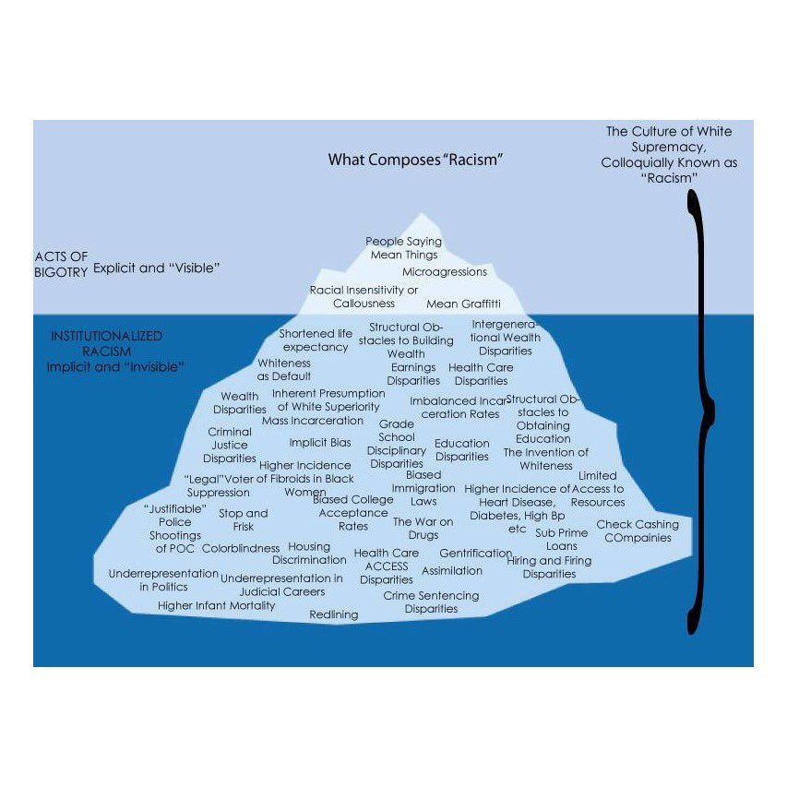
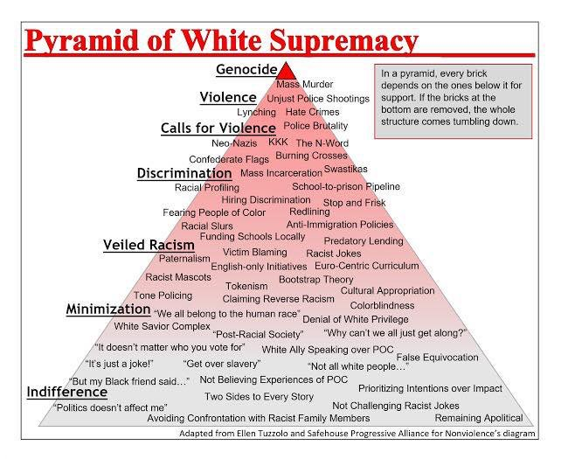

What Do We Mean by Racial Equity?

- The distribution of resources and opportunities is neither determined nor predicted by race, racial bias or racial ideology.
- The structures, systems, practices and cultural narratives in society provide true situational fairness and equal opportunity.
- There is a democratic commitment to dismantle the false narrative of white supremacy and address the legal, political, social, cultural and historical contributors to inequity.
- Families and individuals are able to thrive and flourish in the intersections of all aspects of their identity, including race, religion, gender, orientation, ability, and socioeconomic background.
- The most vulnerable communities in society have access to mechanisms to achieve social mobility and voice in naming their reality, describing how these systems of oppression play out, and developing solutions which draw upon their assets.
- All people, cultures and identities are equally valued and recognized under the belief that strength comes through the diversity and expression of our shared humanity.

Racial Equity Looks the Same Across Systems
- African Americans are 2.3 times more likely to experience infant death (CDC).
- African Americans are 1.9 times more likely to die of diabetes (CDC).
- African Americans are 1.5 times more likely to be below “proficient” in reading in the 4th grade (NAEP).
- African Americans are 3.7 times more likely to be suspended in K-12 (ED and OCR).
- African Americans are 2.7 times more likely be searched on a traffic stop (BJS).
- African Americans are 7.0 times more likely to be incarcerated as adults (BJS).
- African Americans are 1.8 times more likely to be identified as victims by the child welfare system (DHHS).
- African Americans are 2.1 times more likely to be in foster care (DHHS).
- African American business owners are 5.2 times more likely to be denied a loan (SBA).
African American business owners are 1.7 times less likely to own a home (SBA).

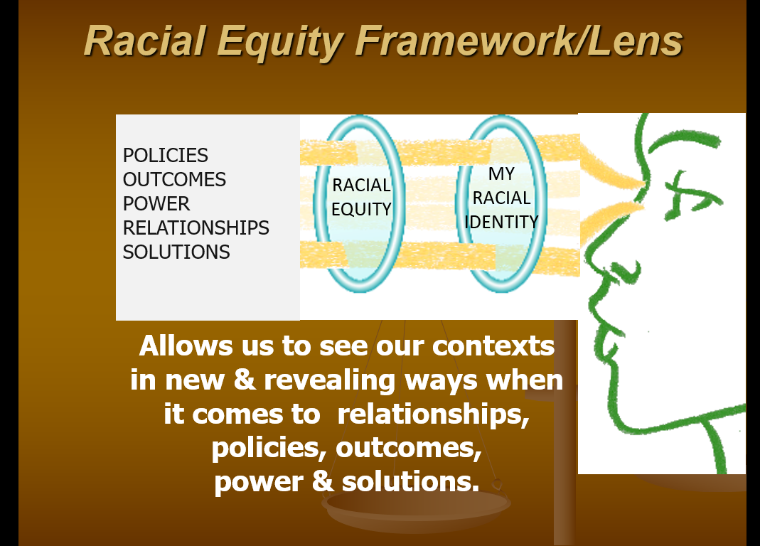

What Can You Do? Finding Your Voice!
- Acknowledge your own bias, own it!
- Be aware & acknowledge the stress of racism (weathering, poor health, etc.).
- Become an Ally……. not a Savior!
- Use your Race Privilege/Advantage.
- Lifelong Learner.

Racial Equity Resources
The History of Race & Racialization
100 years of Immigration to the US, 1919-2019
The Story of Race, A History
Tim Wise on White Privilege
Deconstructing White Privilege with Robin DiAngelo
Cracking the Code, A trip to the Grocery Store with Dr. Joy DeGruy
Cracking the code, System of Inequity
The Black-ish Clip every child should see
Implicit Bias, Peanut Butter and Jelly
Before you OVERHINK THIS
I am NOT Black, You are NOT White
https://www.yesmagazine.org/issue/dirt/opinion/2019/02/21/22-race-related-films-that-will-make-you-laugh-cry-and-think-differently/?fbclid=IwAR0BzzsuFhiwwxaldCt2ZClsqxQJ2WVmjJGavw1Gwu2JXGduGm-wnes78-M
https://library.mwcc.edu/racialinjusticestart

RACIAL EQUITY GLOSSARY

Accountability
In the context of racial equity work, accountability refers to the ways in which individuals and communities hold themselves to their goals and actions and acknowledge the values and groups to which they are responsible.
To be accountable, one must be visible, with a transparent agenda and process. Invisibility defies examination; it is, in fact, employed in order to avoid detection and examination. Accountability demands commitment. It might be defined as “what kicks in when convenience runs out.” Accountability requires some sense of urgency and becoming a true stakeholder in the outcome. Accountability can be externally imposed (legal or organizational requirements), or internally applied (moral, relational, faith-based, or recognized as some combination of the two) on a continuum from the institutional and organizational level to the individual level. From a relational point of view, accountability is not always doing it right. Sometimes it’s really about what happens after it’s done wrong.
SOURCE: Accountability and White Anti-Racist Organizing: Stories from Our Work, Bonnie Berman Cushing with Lila Cabbil, Margery Freeman, Jeff Hitchcock, and Kimberly Richards (2010). See also RacialEquityTools.org, “PLAN / Change Process / Accountability”

Ally
- Someone who makes the commitment and effort to recognize their privilege (based on gender, class, race, sexual identity, etc.) and work in solidarity with oppressed groups in the struggle for justice. Allies understand that it is in their own interest to end all forms of oppression, even those from which they may benefit in concrete ways.
- Allies commit to reducing their own complicity or collusion in oppression of those groups and invest in strengthening their own knowledge and awareness of oppression.
SOURCE:
- OpenSource Leadership Strategies, “The Dynamic System of Power, Privilege, and Oppression” (2008).
- Center for Assessment and Policy Development.
Anti-Black
The Council for Democratizing Education defines anti-Blackness as being a two-part formation that both voids Blackness of value, while systematically marginalizing Black people and their issues. The first form of anti-Blackness is overt racism. Beneath this anti-Black racism is the covert structural and systemic racism which categorically predetermines the socioeconomic status of Blacks in this country. The structure is held in place by anti-Black policies, institutions, and ideologies.
The second form of anti-Blackness is the unethical disregard for anti-Black institutions and policies. This disregard is the product of class, race, and/or gender privilege certain individuals experience due to anti-Black institutions and policies. This form of anti-Blackness is protected by the first form of overt racism.
SOURCE: The Movement for Black Lives (M4BL), “Glossary.”
Anti-Racism
Anti-Racism is defined as the work of actively opposing racism by advocating for changes in political, economic, and social life. Anti-racism tends to be an individualized approach, and set up in opposition to individual racist behaviors and impacts.
SOURCE: Race Forward, “Race Reporting Guide” (2015).
Anti-Racist
An anti-racist is someone who is supporting an antiracist policy through their actions or expressing antiracist ideas. This includes the expression of ideas that racial groups are equals and do not need developing, and supporting policies that reduce racial inequity.
SOURCE: Ibram X. Kendi, How To Be An Antiracist, Random House, 2019.
Anti-Racist Ideas
An antiracist idea is any idea that suggests the racial groups are equals in all of their apparent difference and that there is nothing wrong with any racial group. Antiracists argue that racist policies are the cause of racial injustices.
SOURCE: Ibram X. Kendi, How To Be An Antiracist, Random House, 2019.
Assimilationist
One who is expressing the racist idea that a racial group is culturally or behaviorally inferior and is supporting cultural or behavioral enrichment programs to develop that racial group.
SOURCE: Ibram X. Kendi, How To Be An Antiracist, Random House, 2019.
Bigotry
Intolerant prejudice that glorifies one’s own group and denigrates members of other groups.
SOURCE: National Conference for Community and Justice, St. Louis Region. Unpublished handout used in the Dismantling Racism Institute program.
Black Lives Matter
A political movement to address systemic and state violence against African Americans. Per the Black Lives Matter organizers: “In 2013, three radical Black organizers—Alicia Garza, Patrisse Cullors, and Opal Tometi—created a Black-centered political will and movement building project called #BlackLivesMatter. It was in response to the acquittal of Trayvon Martin’s murderer, George Zimmerman. The project is now a member-led global network of more than 40 chapters. [Black Lives Matter] members organize and build local power to intervene in violence inflicted on Black communities by the state and vigilantes. Black Lives Matter is an ideological and political intervention in a world where Black lives are systematically and intentionally targeted for demise. It is an affirmation of Black folks’ humanity, our contributions to this society, and our resilience in the face of deadly oppression.”
SOURCE: Black Lives Matter, “Herstory” (accessed 7 October 2019).
Caucusing (Affinity Groups)
A caucus is an intentionally created space for those who share an identity to convene for learning, support, and connections. Caucuses based on racial identity are often comprised, respectively, of people of color, white people, people who hold multiracial identities, or people who share specific racial or ethnic identities.

To advance racial equity, there is work for white people and people of color to do separately and together. Caucuses provide spaces for people to work within their own racial/ethnic groups. For white people, a caucus provides time and space to work explicitly and intentionally on understanding white culture and white privilege and to increase one’s critical analysis around these concepts. A white caucus also puts the onus on white people to teach each other about these ideas, rather than placing a burden on people of color to teach them. For people of color, a caucus is a place to work with peers to address the impact of racism, to interrupt experiences of internalized racism, and to create a space for healing and working for individual and collective liberation. At times, people of color may also break into more specific race-based caucuses, sometimes based on experiences with a particular issue, for example police violence, immigration, or land rights. Groups that use caucuses in their organizational racial equity work, especially in workplaces and coalitions, generally meet separately and create a process to rejoin and work together collectively.
SOURCE: RacialEquityTools.org, “ACT / Strategies / Caucus and Affinity Groups”
Collusion
When people act to perpetuate oppression or prevent others from working to eliminate oppression.
Example: Able-bodied people who object to strategies for making buildings accessible because of the expense.
SOURCE: Teaching for Diversity and Social Justice: A Sourcebook, edited by Maurianne Adams, Lee Anne Bell, and Pat Griffin (Routledge, 1997).
Colonization
Colonization can be defined as some form of invasion, dispossession and subjugation of a people. The invasion need not be military; it can begin—or continue—as geographical intrusion in the form of agricultural, urban or industrial encroachments. The result of such incursion is the dispossession of vast amounts of lands from the original inhabitants. This is often legalized after the fact. The long-term result of such massive dispossession is institutionalized inequality. The colonizer/colonized relationship is by nature an unequal one that benefits the colonizer at the expense of the colonized.
Ongoing and legacy colonialism impact power relations in most of the world today. For example, white supremacy as a philosophy was developed largely to justify European colonial exploitation of the Global South (including enslaving African peoples, extracting resources from much of Asia and Latin America, and enshrining cultural norms of whiteness as desirable both in colonizing and colonizer nations). See also: Decolonization.
SOURCE: Emma LaRocque, PhD, “Colonization and Racism,” (Aboriginal Perspectives). Also see Racism and Colonialism, edited by Robert Ross (1982), and Andrea Smith, “Indigeneity, Settler Colonialism, White Supremacy” (Racial Formation in the Twenty-First Century, 2012).
Critical Race Theory
The Critical Race Theory movement considers many of the same issues that conventional civil rights and ethnic studies take up but places them in a broader perspective that includes economics, history, and even feelings and the unconscious. Unlike traditional civil rights, which embraces incrementalism and step by step progress, critical race theory questions the very foundations of the liberal order, including equality theory, legal reasoning, Enlightenment rationalism, and principles of constitutional law.
SOURCE: Richard Delgado and Jean Stefancic, Critical Race Theory: An Introduction, NYU Press, 2001 (2nd ed. 2012, 3rd ed. 2017).
Cultural Appropriation
Theft of cultural elements—including symbols, art, language, customs, etc.—for one’s own use, commodification, or profit, often without understanding, acknowledgement,or respect for its value in the original culture. Results from the assumption of a dominant (i.e. white) culture’s right to take other cultural elements.
SOURCE: Colours of Resistance Archive, “Cultural Appropriation” (accessed 28 June 2013).

Cultural Misappropriation
Cultural misappropriation distinguishes itself from the neutrality of cultural exchange, appreciation, and appropriation because of the instance of colonialism and capitalism; cultural misappropriation occurs when a cultural fixture of a marginalized culture/community is copied, mimicked, or recreated by the dominant culture against the will of the original community and, above all else, commodified. One can understand the use of “misappropriation” as a distinguishing tool because it assumes that there are 1) instances of neutral appropriation, 2) the specifically referenced instance is non-neutral and problematic, even if benevolent in intention, 3) some act of theft or dishonest attribution has taken place, and 4) moral judgement of the act of appropriation is subjective to the specific culture from which is being engaged.
SOURCE: Devyn Springer, “Resources on What ‘Cultural Appropriation’ Is and Isn’t” (2018, accessed 7 October 2019).
Cultural Racism
Cultural racism refers to representations, messages and stories conveying the idea that behaviors and values associated with white people or “whiteness” are automatically “better” or more “normal” than those associated with other racially defined groups. Cultural racism shows up in advertising, movies, history books, definitions of patriotism, and in policies and laws. Cultural racism is also a powerful force in maintaining systems of internalized supremacy and internalized racism. It does that by influencing collective beliefs about what constitutes appropriate behavior, what is seen as beautiful, and the value placed on various forms of expression. All of these cultural norms and values in the U.S. have explicitly or implicitly racialized ideals and assumptions (for example, what “nude” means as a color, which facial features and body types are considered beautiful, which child-rearing practices are considered appropriate.)
SOURCE: RacialEquityTools.org, “FUNDAMENTALS / Core Concepts / Racism”
Culture
A social system of meaning and custom that is developed by a group of people to assure its adaptation and survival. These groups are distinguished by a set of unspoken rules that shape values, beliefs, habits, patterns of thinking, behaviors, and styles of communication.
SOURCE: Institute for Democratic Renewal and Project Change Anti-Racism Initiative, A Community Builder's Tool Kit, Appendix I (2000).
Decolonization
- Decolonization may be defined as the active resistance against colonial powers, and a shifting of power towards political, economic, educational, cultural, psychic independence and power that originate from a colonized nation’s own indigenous culture. This process occurs politically and also applies to personal and societal psychic, cultural, political, agricultural, and educational deconstruction of colonial oppression.
- Per Eve Tuck and K. Wayne Yang: “Decolonization doesn’t have a synonym”; it is not a substitute for ‘human rights’ or ‘social justice’, though undoubtedly, they are connected in various ways. Decolonization demands an Indigenous framework and a centering of Indigenous land, Indigenous sovereignty, and Indigenous ways of thinking.
SOURCE:
1. The Movement for Black Lives (M4BL), “Glossary.”
2. Eric Ritskes, “What Is Decolonization and Why Does It Matter?”
See also RacialEquityTools.org, “FUNDAMENTALS / Core Concepts / Decolonization Theory and Practice”

Diaspora
Diaspora is “the voluntary or forcible movement of peoples from their homelands into new regions ...” There is “a common element in all forms of diaspora; these are people who live outside their natal (or imagined natal) territories and recognize that their traditional homelands are reflected deeply in the languages they speak, religions they adopt, and the cultures they produce.”
SOURCE: Leong Yew, “The Culture of Diasporas in the Postcolonial Web” (quoting Ashcroft et al., Key Concepts in Post-Colonial Studies, and Cohen, Global Diasporas: An Introduction).
Discrimination
- The unequal treatment of members of various groups based on race, gender, social class, sexual orientation, physical ability, religion and other categories.
- [In the United States] the law makes it illegal to discriminate against someone on the basis of race, color, religion, national origin, or sex. The law also makes it illegal to retaliate against a person because the person complained about discrimination, filed a charge of discrimination, or participated in an employment discrimination investigation or lawsuit. The law also requires that employers reasonably accommodate applicants’ and employees’ sincerely held religious practices, unless doing so would impose an undue hardship on the operation of the employer’s business.
SOURCE:
1. Institute for Democratic Renewal and Project Change Anti-Racism Initiative, A Community Builder's Tool Kit, Appendix I (2000).
2. U.S. Equal Employment Opportunity Commission, “Laws Enforced by EEOC” (accessed 28 June 2013).
Diversity
Diversity includes all the ways in which people differ, and it encompasses all the different characteristics that make one individual or group different from another. It is all-inclusive and recognizes everyone and every group as part of the diversity that should be valued. A broad definition includes not only race, ethnicity, and gender—the groups that most often come to mind when the term "diversity" is used—but also age, national origin, religion, disability, sexual orientation, socioeconomic status, education, marital status, language, and physical appearance. It also involves different ideas, perspectives, and values.
It is important to note that many activists and thinkers critique diversity alone as a strategy. For instance, Baltimore Racial Justice Action states: “Diversity is silent on the subject of equity. In an anti-oppression context, therefore, the issue is not diversity, but rather equity. Often when people talk about diversity, they are thinking only of the “non-dominant” groups.”
SOURCE: UC Berkeley Center for Equity, Inclusion and Diversity, “Glossary of Terms” (page 34 in 2009 Strategic Plan). Baltimore Racial Justice Action, “Our Definitions” (2018).
Ethnicity
A social construct that divides people into smaller social groups based on characteristics such as shared sense of group membership, values, behavioral patterns, language, political and economic interests, history, and ancestral geographical base.
Examples of different ethnic groups are: Cape Verdean, Haitian, African American (Black); Chinese, Korean, Vietnamese (Asian); Cherokee, Mohawk, Navaho (Native American); Cuban, Mexican, Puerto Rican (Latino); Polish, Irish, and Swedish (White).
SOURCE: Teaching for Diversity and Social Justice: A Sourcebook, edited by Maurianne Adams, Lee Anne Bell, and Pat Griffin, Routledge, 1997.

Implicit Bias
Also known as unconscious or hidden bias, implicit biases are negative associations that people unknowingly hold. They are expressed automatically, without conscious awareness. Many studies have indicated that implicit biases affect individuals’ attitudes and actions, thus creating real-world implications, even though individuals may not even be aware that those biases exist within themselves. Notably, implicit biases have been shown to trump individuals’ stated commitments to equality and fairness, thereby producing behavior that diverges from the explicit attitudes that many people profess. The Implicit Association Test (IAT) is often used to measure implicit biases with regard to race, gender, sexual orientation, age, religion, and other topics.
SOURCE: Cheryl Staats, State of the Science: Implicit Bias Review 2013, Kirwan Institute, The Ohio State University. See also RacialEquityTools.org, “ACT / Communicating / Implicit Bias”
Inclusion
Authentically bringing traditionally excluded individuals and/or groups into processes, activities, and decision/policy making in a way that shares power.
SOURCE: OpenSource Leadership Strategies
Indigeneity
Indigenous populations are composed of the existing descendants of the peoples who inhabited the present territory of a country wholly or partially at the time when persons of a different culture or ethnic origin arrived there from other parts of the world, overcame them and, by conquest, settlement, or other means, reduced them to a non-dominant or colonial condition; who today live more in conformity with their particular social, economic, and cultural customs and traditions than with the institutions of the country of which they now form part, under a State structure which incorporates mainly national, social, and cultural characteristics of other segments of the population which are predominant.
(Examples: Maori in territory now defined as New Zealand; Mexicans in territory now defined as Texas, California, New Mexico, Arizona, Utah, Nevada, and parts of Colorado, Wyoming, Kansas, and Oklahoma; Native American tribes in territory now defined as the United States.)
SOURCE: United Nations Permanent Forum on Indigenous Issues (2010, page 9), originally presented in the preliminary report of the Special Rapporteur of the UN Commission on Human Rights, José Martínez Cobo (1972, page 10).
Individual Racism
Individual racism refers to the beliefs, attitudes, and actions of individuals that support or perpetuate racism. Individual racism can be deliberate, or the individual may act to perpetuate or support racism without knowing that is what he or she is doing.
Examples:
- Telling a racist joke, using a racial epithet, or believing in the inherent superiority of whites over other groups.
- Avoiding people of color whom you do not know personally, but not whites whom you do not know personally (e.g., white people crossing the street to avoid a group of Latino/a young people; locking their doors when they see African American families sitting on their doorsteps in a city neighborhood; or not hiring a person of color because “something doesn’t feel right”).
- Accepting things as they are (a form of collusion).
SOURCE: Flipping the Script: White Privilege and Community Building by Maggie Potapchuk, Sally Leiderman, Donna Bivens, and Barbara Major (2005).

Institutional Racism
Institutional racism refers specifically to the ways in which institutional policies and practices create different outcomes for different racial groups. The institutional policies may never mention any racial group, but their effect is to create advantages for whites and oppression and disadvantage for people from groups classified as people of color.
Examples:
- Government policies that explicitly restricted the ability of people to get loans to buy or improve their homes in neighborhoods with high concentrations of African Americans (also known as “red-lining”).
- City sanitation department policies that concentrate trash transfer stations and other environmental hazards disproportionately in communities of color.
SOURCE: Flipping the Script: White Privilege and Community Building by Maggie Potapchuk, Sally Leiderman, Donna Bivens, and Barbara Major (2005).
Internalized Racism
Internalized racism is the situation that occurs in a racist system when a racial group oppressed by racism supports the supremacy and dominance of the dominating group by maintaining or participating in the set of attitudes, behaviors, social structures, and ideologies that undergird the dominating group’s power. It involves four essential and interconnected elements:
- Decision-making - Due to racism, people of color do not have the ultimate decision-making power over the decisions that control our lives and resources. As a result, on a personal level, we may think white people know more about what needs to be done for us than we do. On an interpersonal level, we may not support each other’s authority and power – especially if it is in opposition to the dominating racial group. Structurally, there is a system in place that rewards people of color who support white supremacy and power and coerces or punishes those who do not.
- Resources - Resources, broadly defined (e.g. money, time, etc), are unequally in the hands and under the control of white people. Internalized racism is the system in place that makes it difficult for people of color to get access to resources for our own communities and to control the resources of our community. We learn to believe that serving and using resources for ourselves and our particular community is not serving “everybody.”
- Standards - With internalized racism, the standards for what is appropriate or “normal” that people of color accept are white people’s or Eurocentric standards. We have difficulty naming, communicating and living up to our deepest standards and values, and holding ourselves and each other accountable to them.
- Naming the problem - There is a system in place that misnames the problem of racism as a problem of or caused by people of color and blames the disease – emotional, economic, political, etc. – on people of color. With internalized racism, people of color might, for example, believe we are more violent than white people and not consider state-sanctioned political violence or the hidden or privatized violence of white people and the systems they put in place and support.
SOURCE: Donna Bivens, Internalized Racism: A Definition (Women’s Theological Center, 1995).

Interpersonal Racism
Interpersonal racism occurs between individuals. Once we bring our private beliefs into our interaction with others, racism is now in the interpersonal realm.
Examples: public expressions of racial prejudice, hate, bias, and bigotry between individuals
SOURCE: Chronic Disparity: Strong and Pervasive Evidence of Racial Inequalities by Keith Lawrence and Terry Keleher (2004).
Intersectionality
- Exposing [one’s] multiple identities can help clarify the ways in which a person can simultaneously experience privilege and oppression. For example, a Black woman in America does not experience gender inequalities in exactly the same way as a white woman, nor racial oppression identical to that experienced by a Black man. Each race and gender intersection produces a qualitatively distinct life.
- Per Kimberlé Williams Crenshaw: Intersectionality is simply a prism to see the interactive effects of various forms of discrimination and disempowerment. It looks at the way that racism, many times, interacts with patriarchy, heterosexism, classism, xenophobia — seeing that the overlapping vulnerabilities created by these systems actually create specific kinds of challenges. “Intersectionality 102,” then, is to say that these distinct problems create challenges for movements that are only organized around these problems as separate and individual. So when racial justice doesn’t have a critique of patriarchy and homophobia, the particular way that racism is experienced and exacerbated by heterosexism, classism etc., falls outside of our political organizing. It means that significant numbers of people in our communities aren’t being served by social justice frames because they don’t address the particular ways that they’re experiencing discrimination.
SOURCE:
1. Intergroup Resources, “Intersectionality” (2012).
2. Otamere Guobadia, “Kimberlé Crenshaw and Lady Phyll Talk Intersectionality, Solidarity, and Self-Care” (2018).
See also RacialEquityTools.org, “FUNDAMENTALS / Core Concepts / Intersectionality”
Microaggression
The everyday verbal, nonverbal, and environmental slights, snubs, or insults, whether intentional or unintentional, which communicate hostile, derogatory, or negative messages to target persons based solely upon their marginalized group membership.
SOURCE: Derald Wing Sue, PhD, “Microaggressions: More than Just Race” (Psychology Today, 17 November 2010).
Model Minority
A term created by sociologist William Peterson to describe the Japanese community, whom he saw as being able to overcome oppression because of their cultural values.
While individuals employing the Model Minority trope may think they are being complimentary, in fact the term is related to colorism and its root, anti-Blackness. The model minority myth creates an understanding of ethnic groups, including Asian Americans, as a monolith, or as a mass whose parts cannot be distinguished from each other. The model minority myth can be understood as a tool that white supremacy uses to pit people of color against each other in order to protect its status.
SOURCE: Asian American Activism: The Continuing Struggle, “Glossary” (2016).
Movement Building
Movement building is the effort of social change agents to engage power holders and the broader society in addressing a systemic problem or injustice while promoting an alternative vision or solution. Movement building requires a range of intersecting approaches through a set of distinct stages over a long-term period of time. Through movement building, organizers can:
- Propose solutions to the root causes of social problems.
- Enable people to exercise their collective power.
- Humanize groups that have been denied basic human rights and improve conditions for the groups affected.
- Create structural change by building something larger than a particular organization or campaign.
- Promote visions and values for society based on fairness, justice, and democracy.
SOURCE: Julie Quiroz-Martinez, From the Roots: Building the Power of Communities of Color to Challenge Structural Racism (Akonadi Foundation, 2010), citing the Movement Strategy Center, which offers these further definitions.
Multicultural Competency
A process of learning about and becoming allies with people from other cultures, thereby broadening our own understanding and ability to participate in a multicultural process. The key element to becoming more culturally competent is respect for the ways that others live in and organize the world and an openness to learn from them.
SOURCE: Paul Kivel, “Multicultural Competence” (2007). See also RacialEquityTools.org, “ACT / Strategies / Multi-cultural Competency”
Oppression
The systematic subjugation of one social group by a more powerful social group for the social, economic, and political benefit of the more powerful social group. Rita Hardiman and Bailey Jackson state that oppression exists when the following 4 conditions are found:
- the oppressor group has the power to define reality for themselves and others,
- the target groups take in and internalize the negative messages about them and end up cooperating with the oppressors (thinking and acting like them),
- genocide, harassment, and discrimination are systematic and institutionalized, so that individuals are not necessary to keep it going, and
- members of both the oppressor and target groups are socialized to play their roles as normal and correct.
Oppression = Power + Prejudice
SOURCE: “What Is Racism?” − Dismantling Racism Works (dRworks) web workbook.
People of Color
Often the preferred collective term for referring to non-White racial groups. Racial justice advocates have been using the term “people of color” (not to be confused with the pejorative “colored people”) since the late 1970s as an inclusive and unifying frame across different racial groups that are not White, to address racial inequities. While “people of color” can be a politically useful term, and describes people with their own attributes (as opposed to what they are not, e.g., “non-White”), it is also important whenever possible to identify people through their own racial/ethnic group, as each has its own distinct experience and meaning and may be more appropriate.
SOURCE: Race Forward, “Race Reporting Guide” (2015).

Power
- Power is unequally distributed globally and in U.S. society; some individuals or groups wield greater power than others, thereby allowing them greater access and control over resources. Wealth, whiteness, citizenship, patriarchy, heterosexism, and education are a few key social mechanisms through which power operates. Although power is often conceptualized as power over other individuals or groups, other variations are power with (used in the context of building collective strength) and power within (which references an individual’s internal strength). Learning to “see” and understand relations of power is vital to organizing for progressive social change.
- Power may also be understood as the ability to influence others and impose one’s beliefs. All power is relational, and the different relationships either reinforce or disrupt one another. The importance of the concept of power to anti-racism is clear: racism cannot be understood without understanding that power is not only an individual relationship but a cultural one, and that power relationships are shifting constantly. Power can be used malignantly and intentionally, but need not be, and individuals within a culture may benefit from power of which they are unaware.
SOURCE:
- Intergroup Resources, “Power” (2012).
- Alberta Civil Liberties Research Centre, “Racism and Power” (2018) / “CARED Glossary” (2020).
Prejudice
A pre-judgment or unjustifiable, and usually negative, attitude of one type of individual or groups toward another group and its members. Such negative attitudes are typically based on unsupported generalizations (or stereotypes) that deny the right of individual members of certain groups to be recognized and treated as individuals with individual characteristics.
SOURCE: Institute for Democratic Renewal and Project Change Anti-Racism Initiative, A Community Builder's Tool Kit, Appendix I (2000).
Privilege
Unearned social power accorded by the formal and informal institutions of society to ALL members of a dominant group (e.g. white privilege, male privilege, etc.). Privilege is usually invisible to those who have it because we’re taught not to see it, but nevertheless it puts them at an advantage over those who do not have it.
SOURCE: Colours of Resistance Archive, “Privilege” (accessed 28 June 2013).
Race
For many people, it comes as a surprise that racial categorization schemes were invented by scientists to support worldviews that viewed some groups of people as superior and some as inferior. There are three important concepts linked to this fact:
- Race is a made-up social construct, and not an actual biological fact.
- Race designations have changed over time. Some groups that are considered “white” in the United States today were considered “non-white” in previous eras, in U.S. Census data and in mass media and popular culture (for example, Irish, Italian, and Jewish people).
- The way in which racial categorizations are enforced (the shape of racism) has also changed over time. For example, the racial designation of Asian American and Pacific Islander changed four times in the 19th century. That is, they were defined at times as white and at other times as not white. Asian Americans and Pacific Islanders, as designated groups, have been used by whites at different times in history to compete with African American labor.

SOURCE:
1–2. PBS, “Race: The Power of an Illusion” (2018–2019 relaunch of 2003 series).
3. Paul Kivel, Uprooting Racism: How White People Can Work for Racial Justice (Gabriola Island, British Columbia: New Society Publishers, 2002), page 141.
Racial and Ethnic Identity
An individual’s awareness and experience of being a member of a racial and ethnic group; the racial and ethnic categories that an individual chooses to describe him or herself based on such factors as biological heritage, physical appearance, cultural affiliation, early socialization, and personal experience.
SOURCE: Teaching for Diversity and Social Justice: A Sourcebook, edited by Maurianne Adams, Lee Anne Bell, and Pat Griffin, Routledge, 1997.
Racial Equity
- Racial equity is the condition that would be achieved if one's racial identity no longer predicted, in a statistical sense, how one fares. When we use the term, we are thinking about racial equity as one part of racial justice, and thus we also include work to address root causes of inequities, not just their manifestation. This includes elimination of policies, practices, attitudes, and cultural messages that reinforce differential outcomes by race or that fail to eliminate them.
- “A mindset and method for solving problems that have endured for generations, seem intractable, harm people and communities of color most acutely, and ultimately affect people of all races. This will require seeing differently, thinking differently, and doing the work differently. Racial equity is about results that make a difference and last.”
SOURCE:
- Center for Assessment and Policy Development.
- OpenSource Leadership Strategies.
Racial Healing
To restore to health or soundness; to repair or set right; to restore to spiritual wholeness.
SOURCE: Michael R. Wenger, Racial Equity Resource Guide (W.K. Kellogg Foundation, 2012).
Racial Identity Development Theory
Racial Identity Development Theory discusses how people in various racial groups and with multiracial identities form their particular self-concept. It also describes some typical phases in remaking that identity based on learning and awareness of systems of privilege and structural racism, cultural, and historical meanings attached to racial categories, and factors operating in the larger socio-historical level (e.g. globalization, technology, immigration, and increasing multiracial population).
SOURCE: New Perspectives on Racial Identity Development: Integrating Emerging Frameworks, edited by Charmaine L. Wijeyesinghe and Bailey W. Jackson (NYU Press, 2012).
Racial Inequity
Racial inequity is when two or more racial groups are not standing on approximately equal footing, such as the percentages of each ethnic group in terms of dropout rates, single family home ownership, access to healthcare, etc.
SOURCE: Ibram X. Kendi, How To Be An Antiracist, Random House, 2019.

Racial Justice
- The systematic fair treatment of people of all races, resulting in equitable opportunities and outcomes for all. Racial justice—or racial equity—goes beyond “anti-racism.” It is not just the absence of discrimination and inequities, but also the presence of deliberate systems and supports to achieve and sustain racial equity through proactive and preventative measures.
- Operationalizing racial justice means reimagining and co-creating a just and liberated world and includes:
- understanding the history of racism and the system of white supremacy and addressing past harms,
- working in right relationship and accountability in an ecosystem (an issue, sector, or community ecosystem) for collective change,
- implementing interventions that use an intersectional analysis and that impact multiple systems,
- centering Blackness and building community, cultural, economic, and political power of Black, Indigenous, and other People of Color (BIPOC), and
- applying the practice of love along with disruption and resistance to the status quo.
SOURCE:
- Race Forward, “Race Reporting Guide” (2015).
- Maggie Potapchuk, “Operationalizing Racial Justice in Non-Profit Organizations” (MP Associates, 2020). This definition is based on and expanded from the one described in Rinku Sen and Lori Villarosa, “Grantmaking with a Racial Justice Lens: A Practical Guide” (Philanthropic Initiative for Racial Equity, 2019).
Racial Reconciliation
Reconciliation involves three ideas. First, it recognizes that racism in America is both systemic and institutionalized, with far–reaching effects on both political engagement and economic opportunities for minorities. Second, reconciliation is engendered by empowering local communities through relationship-building and truth-telling. Lastly, justice is the essential component of the conciliatory process—justice that is best termed as restorative rather than retributive, while still maintaining its vital punitive character.
SOURCE: The William Winter Institute for Racial Reconciliation, Position Statement on Reconciliation (2014).
Racialization
Racialization is the very complex and contradictory process through which groups come to be designated as being of a particular “race” and on that basis subjected to differential and/or unequal treatment. Put simply, “racialization [is] the process of manufacturing and utilizing the notion of race in any capacity” (Dalal, 2002, p. 27). While white people are also racialized, this process is often rendered invisible or normative to those designated as white. As a result, white people may not see themselves as part of a race but still maintain the authority to name and racialize “others.”
SOURCE: Alberta Civil Liberties Research Centre, “Racialization” (2018) / Calgary Anti-Racism Education, “CARED Glossary” (2020).
Racism
Racism = race prejudice + social and institutional power
Racism = a system of advantage based on race
Racism = a system of oppression based on race
Racism = a white supremacy system

Racism is different from racial prejudice, hatred, or discrimination. Racism involves one group having the power to carry out systematic discrimination through the institutional policies and practices of the society and by shaping the cultural beliefs and values that support those racist policies and practices.
SOURCE: “What Is Racism?” − Dismantling Racism Works (dRworks) web workbook.
Racist
One who is supporting a racist policy through their actions or interaction or expressing a racist idea.
SOURCE: Ibram X. Kendi, How To Be An Antiracist, Random House, 2019.
Racist Ideas
A racist idea is any idea that suggests one racial group is inferior or superior to another racial group in any way.

SOURCE: Ibram X. Kendi, How To Be An Antiracist, Random House, 2019.
Racist Policies
A racist policy is any measure that produces or sustains racial inequity between or among racial groups. Policies are written and unwritten laws, rules, procedures, processes, regulations, and guidelines that govern people. There is no such thing as a nonracist or race-neutral policy. Every policy in every institution in every community in every nation is producing or sustaining either racial inequity or equity between racial groups. Racist policies are also expressed through other terms such as “structural racism” or “systemic racism”. Racism itself is institutional, structural, and systemic.
SOURCE: Ibram X. Kendi, How To Be An Antiracist, Random House, 2019.
Reparations
States have a legal duty to acknowledge and address widespread or systematic human rights violations, in cases where the state caused the violations or did not seriously try to prevent them. Reparations initiatives seek to address the harms caused by these violations. They can take the form of compensating for the losses suffered, which helps overcome some of the consequences of abuse. They can also be future oriented—providing rehabilitation and a better life to victims—and help to change the underlying causes of abuse. Reparations publicly affirm that victims are rights-holders entitled to redress.
SOURCE: International Center for Transitional Justice. See also RacialEquityTools.org, “PLAN / Issues / Reparations”
Restorative Justice
Restorative Justice is a theory of justice that emphasizes repairing the harm caused by crime and conflict. It places decisions in the hands of those who have been most affected by a wrongdoing, and gives equal concern to the victim, the offender, and the surrounding community. Restorative responses are meant to repair harm, heal broken relationships, and address the underlying reasons for the offense. Restorative Justice emphasizes individual and collective accountability. Crime and conflict generate opportunities to build community and increase grassroots power when restorative practices are employed.
SOURCE: The Movement for Black Lives (M4BL), “Glossary.”
Settler Colonialism
Settler colonialism refers to colonization in which colonizing powers create permanent or long-term settlement on land owned and/or occupied by other peoples, often by force. This contrasts with colonialism where colonizer’s focus only on extracting resources back to their countries of origin, for example. Settler Colonialism typically includes oppressive governance, dismantling of indigenous cultural forms, and enforcement of codes of superiority (such as white supremacy). Examples include white European occupations of land in what is now the United States, Spain’s settlements throughout Latin America, and the Apartheid government established by White Europeans in South Africa.
Per Dina Gillio-Whitaker, “Settler Colonialism may be said to be a structure, not an historic event, whose endgame is always the elimination of the Natives in order to acquire their land, which it does in countless seen and unseen ways. These techniques are woven throughout the US’s national discourse at all levels of society. Manifest Destiny—that is, the US’s divinely sanctioned inevitability—is like a computer program always operating unnoticeably in the background. In this program, genocide and land dispossession are continually both justified and denied.”
SOURCE: Dina Gilio-Whitaker, “Settler Fragility: Why Settler Privilege Is So Hard to Talk About” (2018).
Structural Racialization
Structural racialization connotes the dynamic process that creates cumulative and durable inequalities based on race. Interactions between individuals are shaped by and reflect underlying and often hidden structures that shape biases and create disparate outcomes even in the absence of racist actors or racist intentions. The presence of structural racialization is evidenced by consistent differences in outcomes in education attainment, family wealth, and even life span.
SOURCE: Systems Thinking and Race: Workshop Summary by john a. powell, Connie Cagampang Heller, and Fayza Bundalli (The California Endowment, 2011).
Structural Racism
- The normalization and legitimization of an array of dynamics – historical, cultural, institutional, and interpersonal – that routinely advantage Whites while producing cumulative and chronic adverse outcomes for people of color. Structural racism encompasses the entire system of White domination, diffused and infused in all aspects of society including its history, culture, politics, economics, and entire social fabric. Structural racism is more difficult to locate in a particular institution because it involves the reinforcing effects of multiple institutions and cultural norms, past and present, continually reproducing old and producing new forms of racism. Structural racism is the most profound and pervasive form of racism – all other forms of racism emerge from structural racism.
- For example, we can see structural racism in the many institutional, cultural, and structural factors that contribute to lower life expectancy for African American and Native American men, compared to white men. These include higher exposure to environmental toxins, dangerous jobs and unhealthy housing stock, higher exposure to and more lethal consequences for reacting to violence, stress, and racism, lower rates of health care coverage, access, and quality of care, and systematic refusal by the nation to fix these things.
SOURCE:
- Chronic Disparity: Strong and Pervasive Evidence of Racial Inequalities by Keith Lawrence, Aspen Institute on Community Change, and Terry Keleher, Applied Research Center, for the Race and Public Policy Conference (2004).
- Flipping the Script: White Privilege and Community Building by Maggie Potapchuk, Sally Leiderman, Donna Bivens, and Barbara Major (2005).
Targeted Universalism
Targeted universalism means setting universal goals pursued by targeted processes to achieve those goals. Within a targeted universalism framework, universal goals are established for all groups concerned. The strategies developed to achieve those goals are targeted, based upon how different groups are situated within structures, culture, and across geographies to obtain the universal goal. Targeted universalism is goal oriented, and the processes are directed in service of the explicit, universal goal.

SOURCE: Targeted Universalism: Policy & Practice – A Primer by john a. powell, Stephen Menendian, and Wendy Ake (Haas Institute for a Fair and Inclusive Society, 2019). See also RacialEquityTools.org, “FUNDAMENTALS / Core Concepts / Theory”
White Fragility
A state in which even a minimum amount of racial stress becomes intolerable [for white people], triggering a range of defensive moves. These moves include the outward display of emotions such as anger, fear, and guilt, and behaviors such as argumentation, silence, and leaving the stress-inducing situation. These behaviors, in turn, function to reinstate white racial equilibrium.
SOURCE: Robin DiAngelo, “White Fragility” (International Journal of Critical Pedagogy, 2011).
White Privilege
1. Refers to the unquestioned and unearned set of advantages, entitlements, benefits and choices bestowed on people solely because they are white. Generally white people who experience such privilege do so without being conscious of it.

2. Structural White Privilege: A system of white domination that creates and maintains belief systems that make current racial advantages and disadvantages seem normal. The system includes powerful incentives for maintaining white privilege and its consequences, and powerful negative consequences for trying to interrupt white privilege or reduce its consequences in meaningful ways. The system includes internal and external manifestations at the individual, interpersonal, cultural and institutional levels.

The accumulated and interrelated advantages and disadvantages of white privilege that are reflected in racial/ethnic inequities in life-expectancy and other health outcomes, income and wealth, and other outcomes, in part through different access to opportunities and resources. These differences are maintained in part by denying that these advantages and disadvantages exist at the structural, institutional, cultural, interpersonal, and individual levels and by refusing to redress them or eliminate the systems, policies, practices, cultural norms, and other behaviors and assumptions that maintain them.

Interpersonal White Privilege: Behavior between people that consciously or unconsciously reflects white superiority or entitlement.

Cultural White Privilege: A set of dominant cultural assumptions about what is good, normal or appropriate that reflects Western European white world views and dismisses or demonizes other world views.

Institutional White Privilege: Policies, practices and behaviors of institutions—such as schools, banks, non-profits or the Supreme Court—that have the effect of maintaining or increasing accumulated advantages for those groups currently defined as white, and maintaining or increasing disadvantages for those racial or ethnic groups not defined as white. The ability of institutions to survive and thrive even when their policies, practices and behaviors maintain, expand or fail to redress accumulated disadvantages and/or inequitable outcomes for people of color.

SOURCES:
- Peggy McIntosh, “White Privilege and Male Privilege: A Personal Account of Coming to See Correspondences Through Work in Women Studies” (1988).
- Transforming White Privilege: A 21st Century Leadership Capacity, CAPD, MP Associates, World Trust Educational Services (2012).
White Supremacy
The idea (ideology) that white people and the ideas, thoughts, beliefs, and actions of white people are superior to People of Color and their ideas, thoughts, beliefs, and actions. While most people associate white supremacy with extremist groups like the Ku Klux Klan and the neo-Nazis, white supremacy is ever present in our institutional and cultural assumptions that assign value, morality, goodness, and humanity to the white group while casting people and communities of color as worthless (worth less), immoral, bad, and inhuman and “undeserving.” Drawing from critical race theory, the term “white supremacy” also refers to a political or socio-economic system where white people enjoy structural advantage and rights that other racial and ethnic groups do not, both at a collective and an individual level.
SOURCE: “What Is Racism?” − Dismantling Racism Works (dRworks) web workbook.
White Supremacy Culture
- White Supremacy Culture refers to the dominant, unquestioned standards of behavior and ways of functioning embodied by the vast majority of institutions in the United States. These standards may be seen as mainstream, dominant cultural practices; they have evolved from the United States’ history of white supremacy. Because it is so normalized it can be hard to see, which only adds to its powerful hold. In many ways, it is indistinguishable from what we might call U.S. culture or norms – a focus on individuals over groups, for example, or an emphasis on the written word as a form of professional communication. But it operates in even more subtle ways, by actually defining what “normal” is – and likewise, what “professional,” “effective,” or even “good” is. In turn, white culture also defines what is not good, “at risk,” or “unsustainable.” White culture values some ways of thinking, behaving, deciding, and knowing – ways that are more familiar and come more naturally to those from a white, western tradition – while devaluing or rendering invisible other ways. And it does this without ever having to explicitly say so...
- An artificial, historically constructed culture which expresses, justifies, and binds together the United States white supremacy system. It is the glue that binds together white-controlled institutions into systems and white-controlled systems into the global white supremacy system.
SOURCE:
1. Gita Gulati-Partee and Maggie Potapchuk, “Paying Attention to White Culture and Privilege: A Missing Link to Advancing Racial Equity” (The Foundation Review vol. 6: issue 1, 2014).
2. Sharon Martinas and the Challenging White Supremacy Workshop, 4th revision (1995).
Whiteness
- The term white, referring to people, was created by Virginia slave owners and colonial rules in the 17th century. It replaced terms like Christian and Englishman to distinguish European colonists from Africans and indigenous peoples. European colonial powers established whiteness as a legal concept after Bacon’s Rebellion in 1676, during which indentured servants of European and African descent had united against the colonial elite. The legal distinction of white separated the servant class on the basis of skin color and continental origin. The creation of ‘whiteness’ meant giving privileges to some, while denying them to others with the justification of biological and social inferiority.
- Whiteness itself refers to the specific dimensions of racism that serve to elevate white people over people of color. This definition counters the dominant representation of racism in mainstream education as isolated in discrete behaviors that some individuals may or may not demonstrate, and goes beyond naming specific privileges (McIntosh, 1988). Whites are theorized as actively shaped, affected, defined, and elevated through their racialization and the individual and collective consciousness formed within it ... Whiteness is thus conceptualized as a constellation of processes and practices rather than as a discrete entity (i.e., skin color alone). Whiteness is dynamic, relational, and operating at all times and on myriad levels. These processes and practices include basic rights, values, beliefs, perspectives, and experiences purported to be commonly shared by all but which are actually only consistently afforded to white people.

SOURCE:
1. PBS, “Race: The Power of an Illusion” (2018–2019 relaunch of 2003 series).
2. Robin DiAngelo, “White Fragility” (International Journal of Critical Pedagogy, 2011).

